INDEX

|  |  |  |
| --- | --- | --- |
| **S.No** | **Topics** | **Page No** |
| 1. | Conditional statement basic programs | 2 |
| 2. | while basic programs | 19 |
| 3. | for basic programs | 30 |
| 4. | List basic programs | 59 |
| 5. | Set basic programs | 52 |
| 6. | Tuple basic programs | 56 |
| 7. | Dictionaries basic programs | 58 |
| 8. | Functions basic programs | 64 |
| 9. | Module | 67 |
| 10. | File Handling | 68 |
| 11. | String basic programs | 70 |

Chapter 1. Conditional Statement Basic Program

if syntax:

if (condition): statement

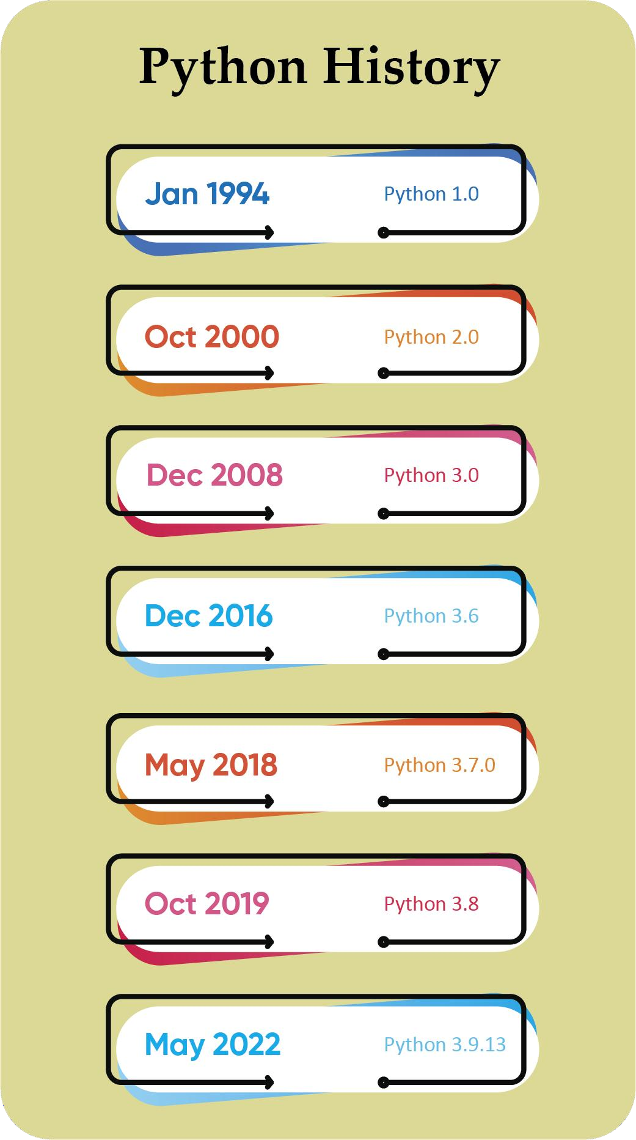

if else syntax:

if (condition): statement

else:

statement

elif syntax:

if (condition): statement

elif (condition):

statement else:

statement

nested if syntax:

if (condition):

if (condition): statement

## To check whether the given age is eligible to vote

Program:

age=int(input("Enter the age")) if age>=18:

print("eligible to vote") else:

print("not eligible to vote")

Output:

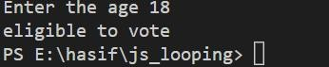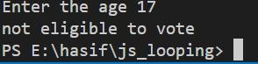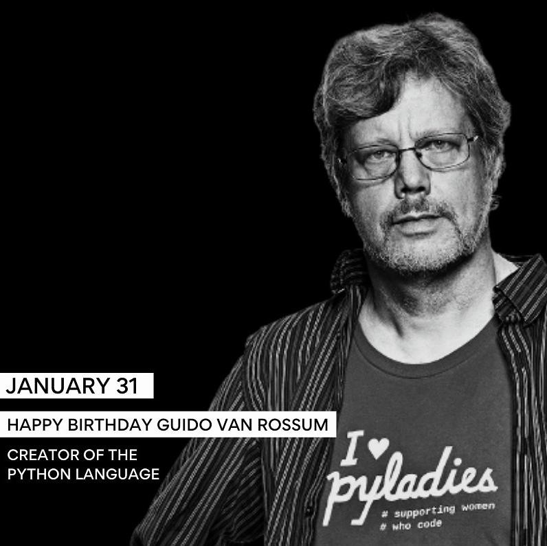

## Find the largest number in given three values

|  |  |  |  |  |
| --- | --- | --- | --- | --- |
| **Program:** |  | | | |
| **a=int(input("enter** | **the** | **value** | **of** | **a"))** |
| **b=int(input("enter** | **the** | **value** | **of** | **b"))** |
| **c=int(input("enter**  **if a>=b and a>=c:** | **the** | **value** | **of** | **c"))** |

**print("A is greater than B and C") elif b>=a and b>=c:**

**print("B is greater than A and C") else:**

**print("C is greater than A and B")**

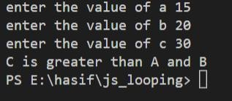Output:

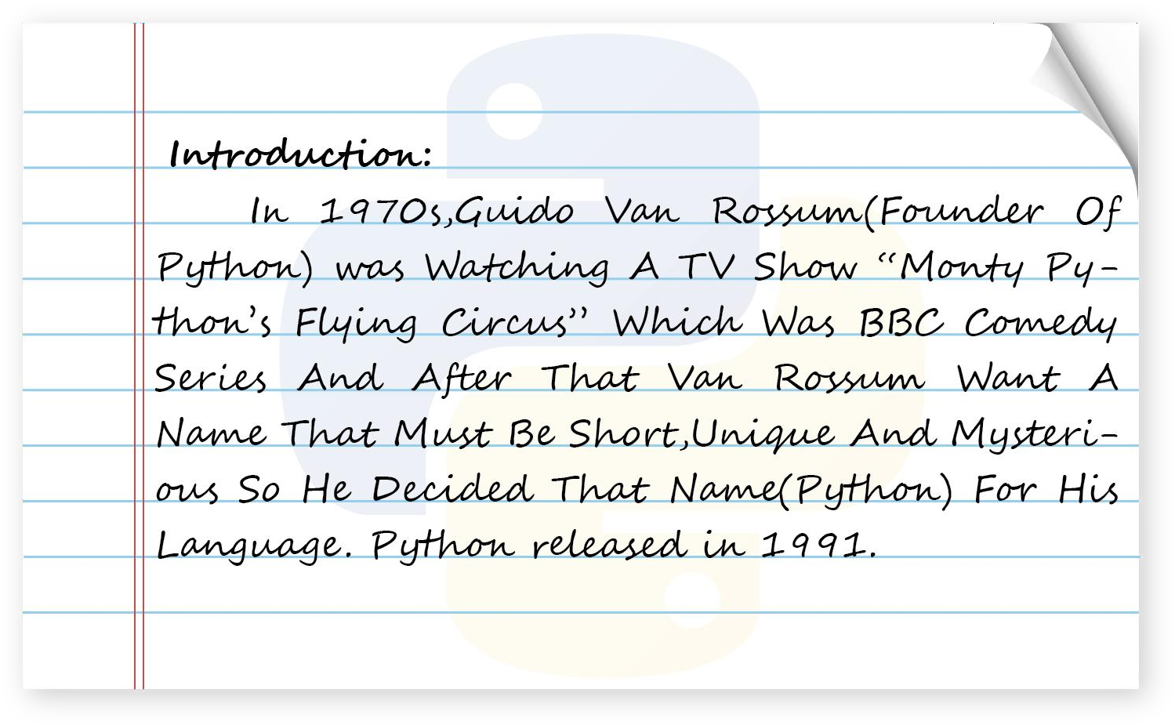

## Write a program to check whether a number entered by a user is even or odd.

Program:

num=int(input("Enter the number")) if num%2==0:

print("Number is Even") else:

print("Number is Odd")

Output:

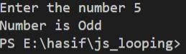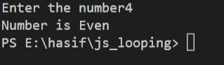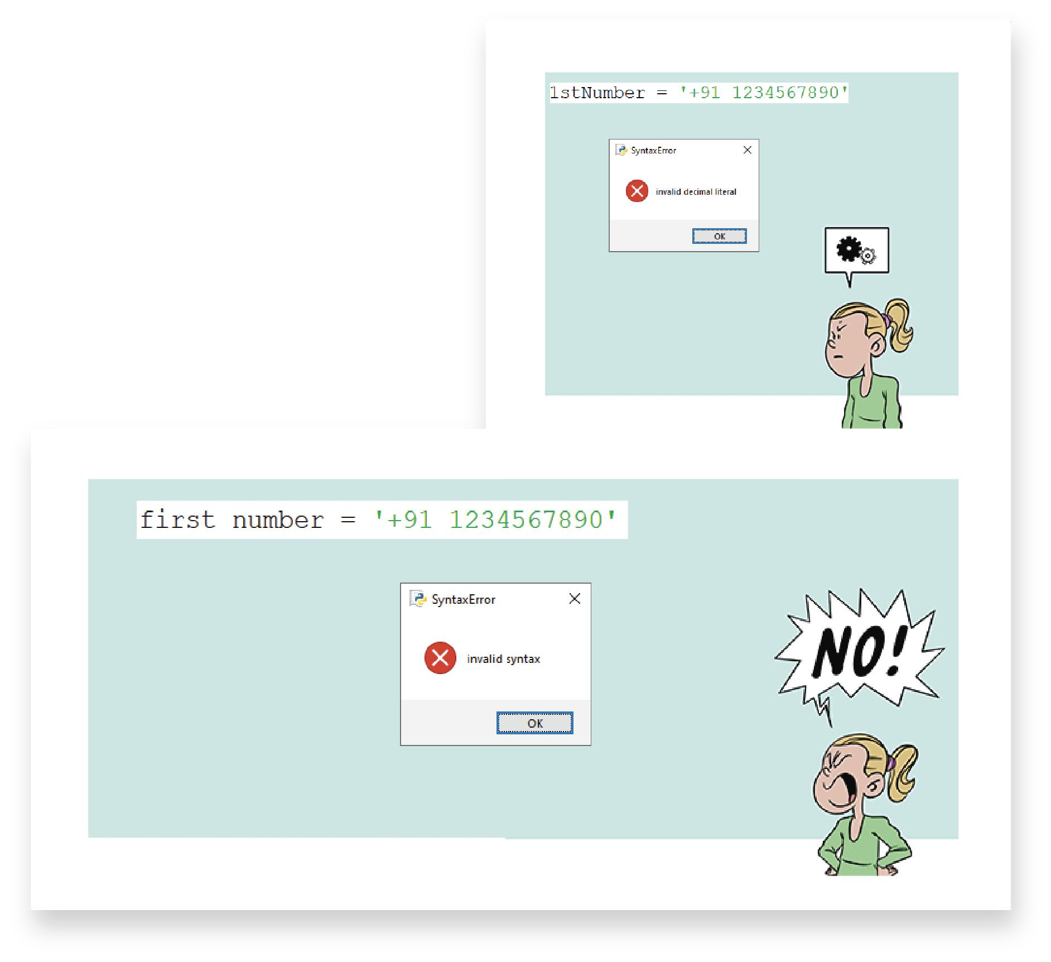

## Write a program to check whether a number is divisible by 7 or not.

Program:

num=int(input("Enter the number")) if num%7==0:

print("Number is divisible") else:

print("Number is not divisible")

Output:

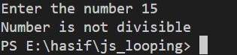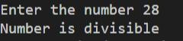

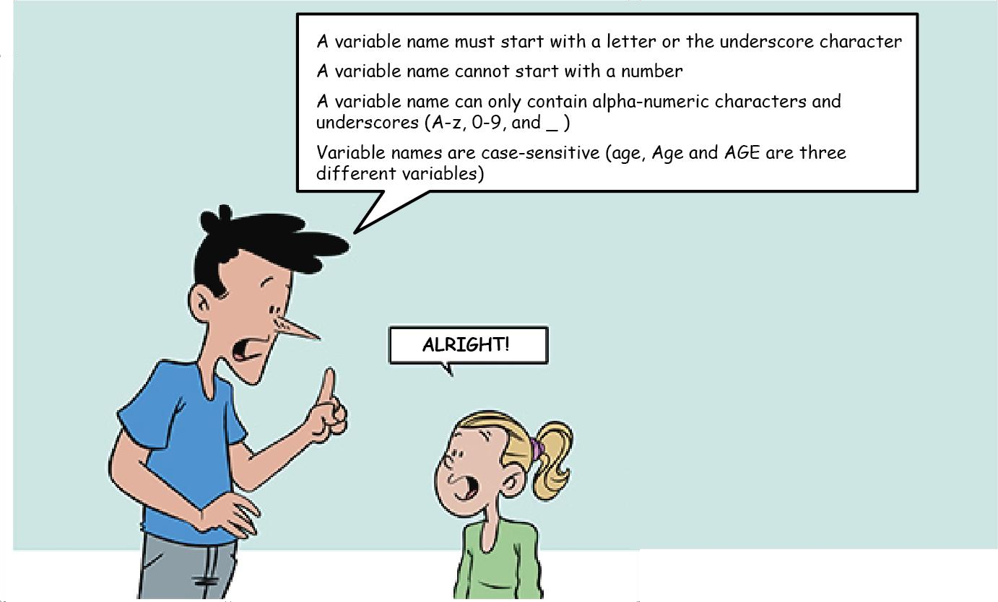

## Write a program to calculate the electricity bill (accept number of unit from user) according to the following criteria.

Unit Price

First 100 units no charge

Next 100 units Rs 5 per unit

After 200 units Rs 10 per unit

(For example if input unit is 350 than total bill amount is Rs2000)

Program:

**amt=0**

**num=int(input("Enter number of electric unit")) if num<=100:**

**amt=0**

**if num>100 and num<=200: amt=(num-100)*5**

**if num>200:**

**amt=500+(num-200)*10 print("Amount to pay :",amt)**

Output:

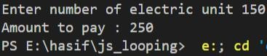

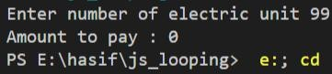

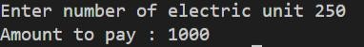

## Write a program to accept percentage from the user and display the grade according to the following criteria

Marks Grade

> 90 A

> 80 and <= 90 B

>= 60 and <= 80 C

below 60 D

Program:

per = int(input("Enter marks")) if per > 90:

print("Grade is A") elif per > 80 and per <=90:

print("Grade is B") elif per >=60 and per <= 80:

print("Grade is C") elif per < 60:

print("Grade is D")

Output:

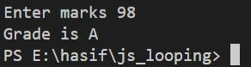

## Write a program to accept the cost price of a bike and display the road tax to be paid according to the following criteria.

Cost price (in Rs) Tax

> 100000 15%

> 50000 and <= 100000 10%

<= 50000 5%

Program:

tax = 0

pr = int(input("Enter the price of bike")) if pr > 100000:

tax = 15/100*pr

elif pr >50000 and pr <=100000:

|  |  |  |
| --- | --- | --- |
| **tax =**  **else:** | **10/100*pr** | |
| **tax =** | **5/100*pr** |  |
| **print("Tax** | **to be paid** | **",tax)** |

Output:

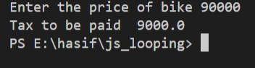

## Write a program to check whether a year is a leap year or not.

Program:

yr=int(input("Enter the year")) if yr%100==0:

if yr%400==0:

print("Entered year is leap year")

else:

else:

print("Entered year is not a leap year")

if yr%4==0:

print("Entered year is leap year") else:

print("Entered year is not a leap year")

Output:

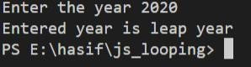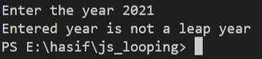

## Write a program to check whether a number (accepted from a user) is positive or negative.

Program:

num1 = int(input("Enter first number")) if num1 > 0 :

print("Number is positive") else:

print("Number is negative")

Output:

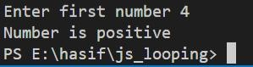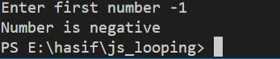

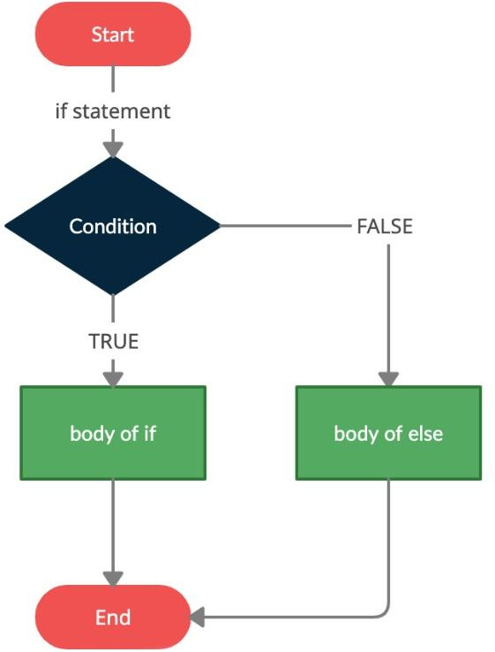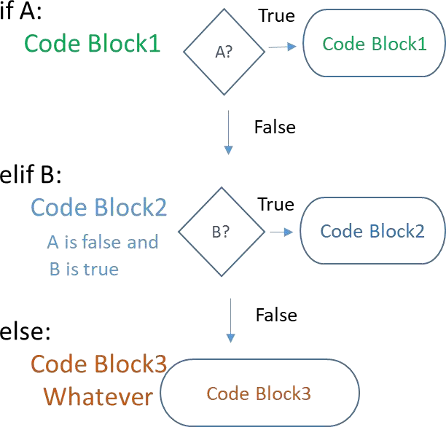

## Write a program to accept a number from 1 to 7 and display the name of the day like 1 for Sunday , 2 for Monday and so on.

Program:

num=int(input("Enter any number between 1 to 7 : ")) if num==1:

print("Sunday") elif num==2:

print("Monday") elif num==3:

print("Tuesday") elif num==4:

print("Wednesday") elif num==5:

print("Thursday") elif num==6:

print("Friday") elif num==7:

print("Saturday") else:

print("Please enter number between 1 to 7")

Output:

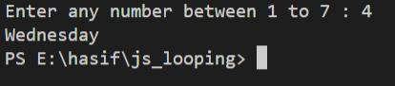

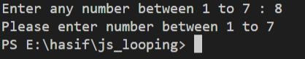

## Write a program to check whether the last digit of a number( entered by user ) is divisible by 3 or not.

Program:

num=int(input("Enter any number")) ld=num%10

if ld%3==0:

print("Last digit of number is divisible by 3 ") else:

print("Last digit of number is not divisible by 3

")

Output:

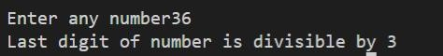



## Write a program to accept a number from 1 to 12 and display name of the month and days in that month like 1 for January and number of days 31 and so on.

**Program:**

**num=int(input("Enter any number between 1 to 12 : ")) if num==1:**

**print("January") elif num==2:**

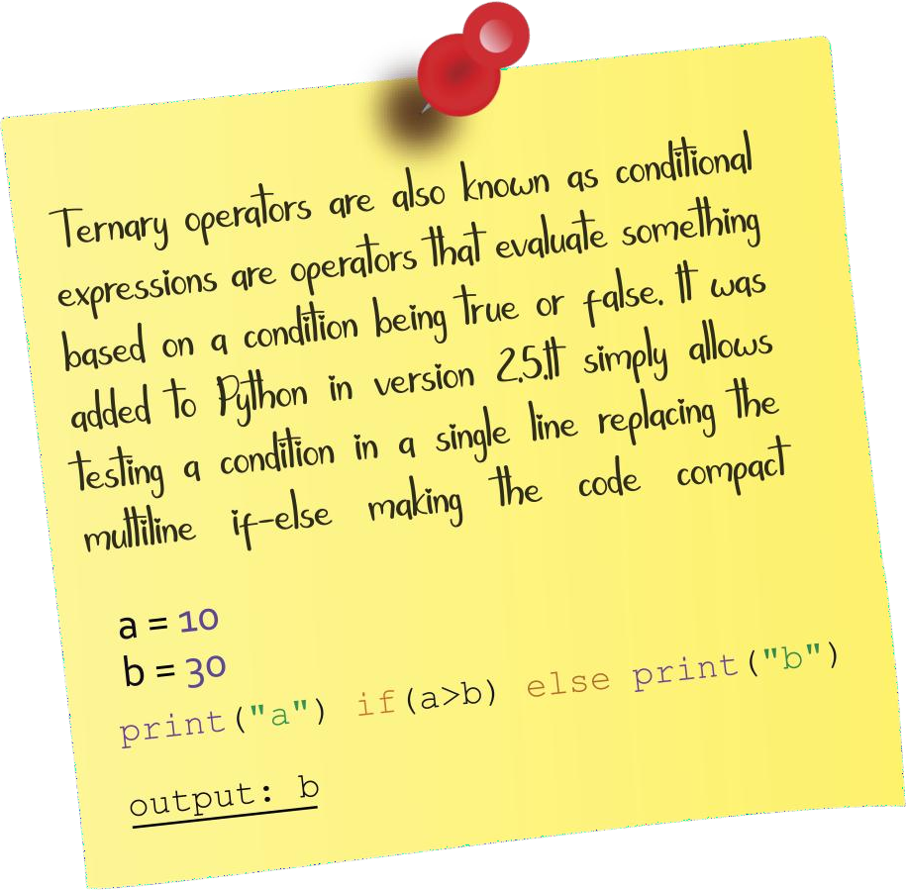**print("February") elif num==3:**

**print("March") elif num==4:**

**print("April") elif num==5:**

**print("May") elif num==6:**

**print("June") elif num==7:**

**print("July") elif num==8:**

**print("August") elif num==9:**

**print("September") elif num==10:**

**print("October") elif num==11:**

**print("November") elif num==12:**

**print("December") else:**

**print("Please enter number between 1 to 12")**

Output:



## Write a program to check whether a number entered is a three digit number or not.

Program:

num1 = input("Enter any number") l=len(num1)

if l != 3:

print("Enter three digit number") else:

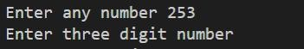print("Middle digit is ",(int(num1)%100//10)) Output:

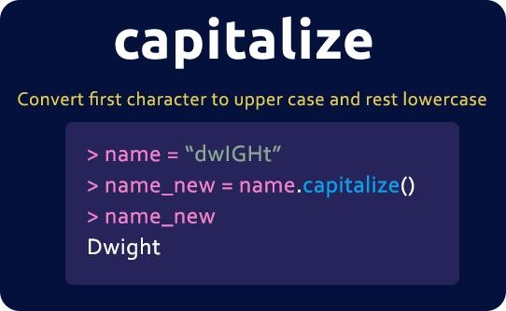

## Write a program to check whether a person is senior citizen or not.

Program:

age=int(input("Enter your age")) if age >=60:

print("Senior Citizen") else:

print("Not a Senior Citizen")

Output:

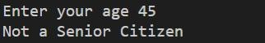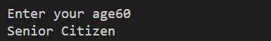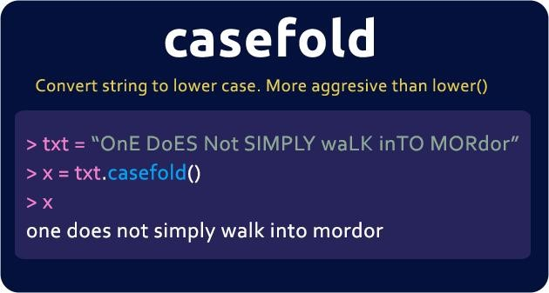

## Accept the following from the user and calculate the percentage of class attended:

1. Total number of working days

## Total number of days for absent

After calculating percentage show that, If the percentage is less than 75, than student will not be able to sit in exam.

Program:

nd = int(input("Enter total number of working days")) na = int(input("Enter number of days absent")) per=(nd-na)/nd*100

print("Your attendance is ",per) if per <75 :

print("You are not eligible for exams") else:

print("You are eligible for writing exam")

Output:

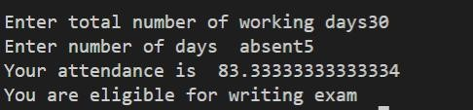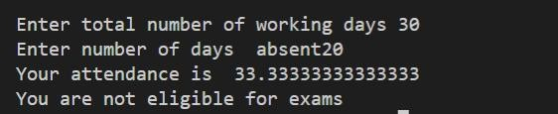

## A company decided to give bonus to employee according to following criteria:

Time period of Service Bonus More than 10 years 10%

## >=6 and <=10 8%

Less than 6 years 5%

## Ask user for their salary and years of service and print the net bonus amount.

Program:

ser=int(input("Enter the time period of service")) sal =int(input("Enter your salary"))

if ser > 10:

b=10/100*sal

if ser >=6 and ser <=10: b = 8/100*sal

if ser < 6:

b = 5/100*sal print("Bonus is ", b)

Output:

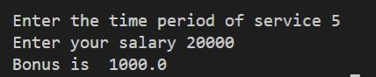

## Accept three sides of a triangle and check whether it is an equilateral, isosceles or scalene triangle.

Note :

## An equilateral triangle is a triangle in which all three sides are equal.

A scalene triangle is a triangle that has three unequal sides.

## An isosceles triangle is a triangle with (at least) two equal sides.

Program:

s1=int(input("Enter first side of triangle")) s2=int(input("Enter second side of triangle")) s3=int(input("Enter third side of triangle")) if s1==s2 and s2 == s3:

print("Equilateral triangle")

if (s1==s2 and s2!=s3) or (s2==s3 and s2!=s1) or (s1==s3 and s1!=s2):

print("Isosceles Triangle") if s1!=s2 and s1!=s3 and s2!=s3:

print("Scalene Triangle")

Output:

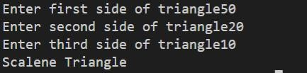

## Accept three numbers from the user and display the second largest number.

Program:

num1=int(input("Enter first number")) num2=int(input("Enter second number")) num3=int(input("Enter third number"))

|  |  |  |  |  |
| --- | --- | --- | --- | --- |
| **if (num1 > num2 and num1 < num3)** | **or (num1** | **<** | **num2** | **and** |
| **num1 > num3):** |  |  |  |  |
| **print("Middle number is " ,** | **num1)** |  |  |  |
| **if (num2 > num1 and num2 < num3)** | **or (num2** | **<** | **num1** | **and** |
| **num2 > num3):** |  |  |  |  |
| **print("Middle number is" , num2)** | |  |  |  |
| **if (num3 > num2 and num3 < num1) or (num3** | | **<** | **num2** | **and** |
| **num3 > num1):** | |  |  |  |
| **print("Middle number is" , num3)** | |  |  |  |

Output:

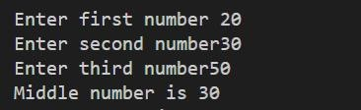

## Accept the kilometers covered and calculate the bill according to the following criteria:

First 10 Km Rs11/km

## Next 90Km Rs 10/km After that **Rs9/km**

Program:

kmc = int(input("Enter the kilometer covered")) if kmc <=10 :

amt = kmc * 11

elif kmc > 10 and kmc <= 100: amt = 110 + (kmc - 10)*10

elif kmc > 100:

amt = 1010 + (kmc - 100)*9 print("Total amount to pay is ", amt)

Output:

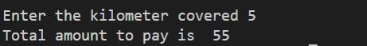

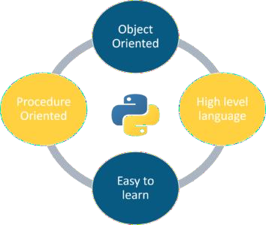

## Write a program to accept two numbers and mathematical operators and perform operation accordingly.

Like:

## Enter First Number: 7 Enter Second Number : 9 Enter operator : +

Your Answer is : 16

Program:

num1=int(input("Enter first number")) num2=int(input("Enter second number")) op=input("Enter mathematical operator") if op=='+':

print("Result is ", num1+num2)

|  |  |  |  |  |
| --- | --- | --- | --- | --- |
| **if** | **op=='-':** |  | | |
|  | **print("Result** | **is** | **",** | **num1-num2)** |
| **if** | **op=='*':** |  |  |  |
|  | **print("Result** | **is** | **",** | **num1*num2)** |
| **if** | **op=='/':** |  |  |  |
|  | **print("Result** | **is** | **",** | **num1/num2)** |
| **if** | **op=='%':** |  |  |  |
|  | **print("Result** | **is** | **",** | **num1%num2)** |
| **if** | **op=='**':** |  |  |  |
|  | **print("Result** | **is** | **",** | **num1**num2)** |
| **if** | **op=='//':** |  |  |  |
|  | **print("Result** | **is** | **",** | **num1//num2)** |

Output:

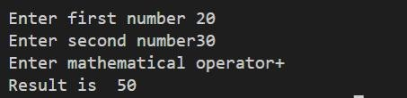

2. Looping basic programs:

while syntax:

while (condition): statement increment/decrement



## Write a program to print the following using a while loop first 10 natural numbers.

Program:

n=int(input("Enter the range")) i=1

while i<=n:

print(i) i+=1

Output:

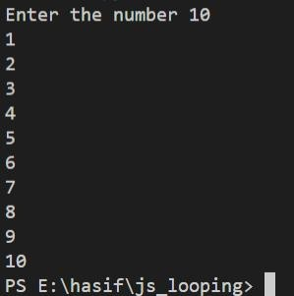

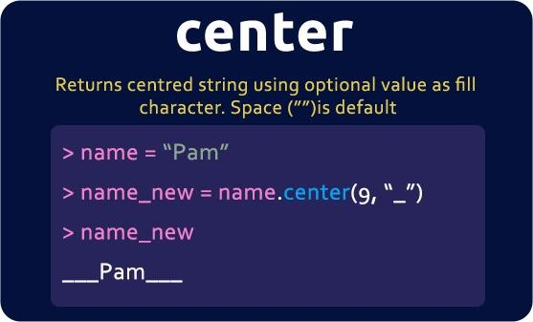

## Write a program to print the following using a while loop first 10 even numbers.

Program:

n=int(input("Enter the range")) i=1

while i<=n:

if i%2==0:

print(i) i+=1

Output:

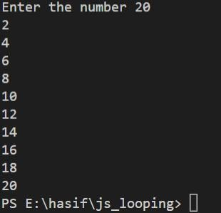

## Write a program to print the first 10 integers and their squares using a while loop.

Program:

n=int(input("Enter the range")) i=1

while i<=n:

print(i*i) i+=1

Output:

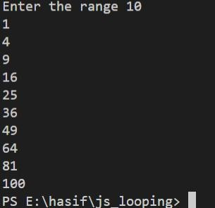

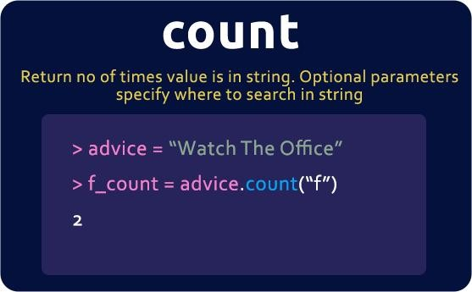

## Write a program to print the sum of the first 10 Natural numbers.

Program:

sum=0 i=1

while i<=10:

sum=sum+i i+=1

print(sum)

Output:

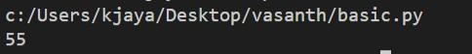

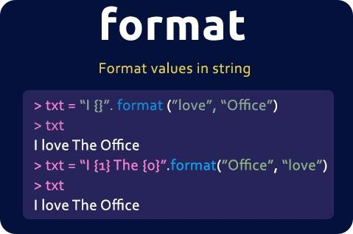

## Write a program to print a table of a number entered from the user.

Program:

n=int(input("enter the range")) n1=int(input("enter the number")) i=1

while i<=n:

print(i,"x",n1,"=",i*n1) i+=1

Output:

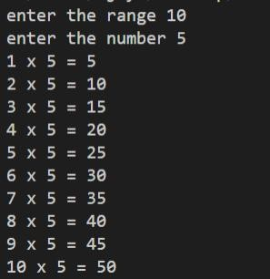

## Write a program to convert Decimal to Binary.

Program:

num = int(input("Enter a positive number: ")) bin = 0

p = 1 n = num

while n>0:

rem = int(n % 2) bin = bin + rem * p p = p*10

n = n/2

print("Binary number of",num,"is",bin) Output:

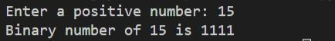

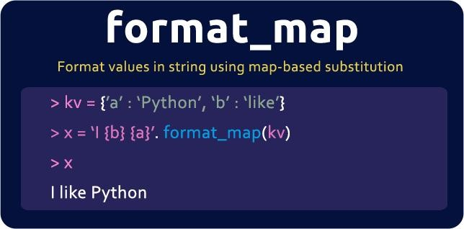

## Write a program to check whether a number is palindrome or not.

Program:

num=int(input("enter the number")) result=0

temp=num while num>0:

rem=num%10

result= result*10+rem num=num//10

if (temp==result):

print("given number is palindrome") else:

print("given number is not palindrome")

Output:

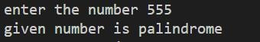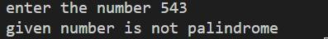

## Write a program to check whether a number is Armstrong or not.

Program:

num=int(input("enter the number")) result=0

temp=num while num>0:

rem=num%10

result= result+rem**3 num=num//10

if (temp==result):

print("given number is Armstrong") else:

print("given number is not Armstrong")

Output:

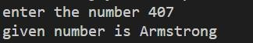

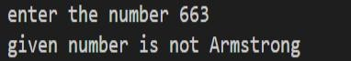

## Write for loop statement to print the following series: 10, 20, 30 … … 300

Program:

num = 10

while (num <= 300) : print(num) num = num +10

Output:

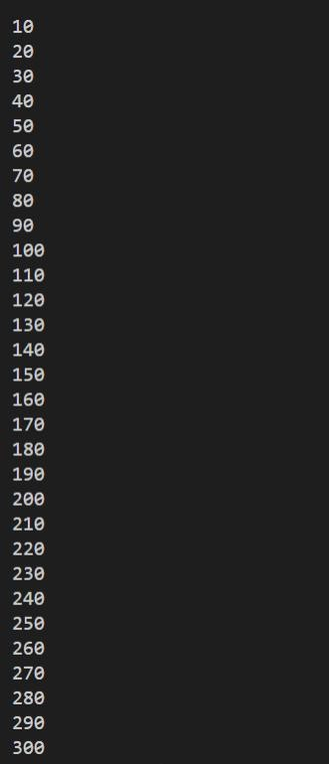

## Write a while loop statement to print the following series

105, 98, 91 ………7.

Program:

num = 105 while(num <= 7) :

print(num) num = num - 7

Output:

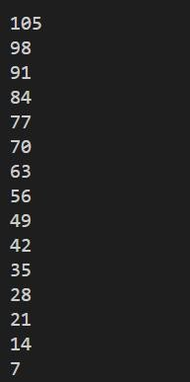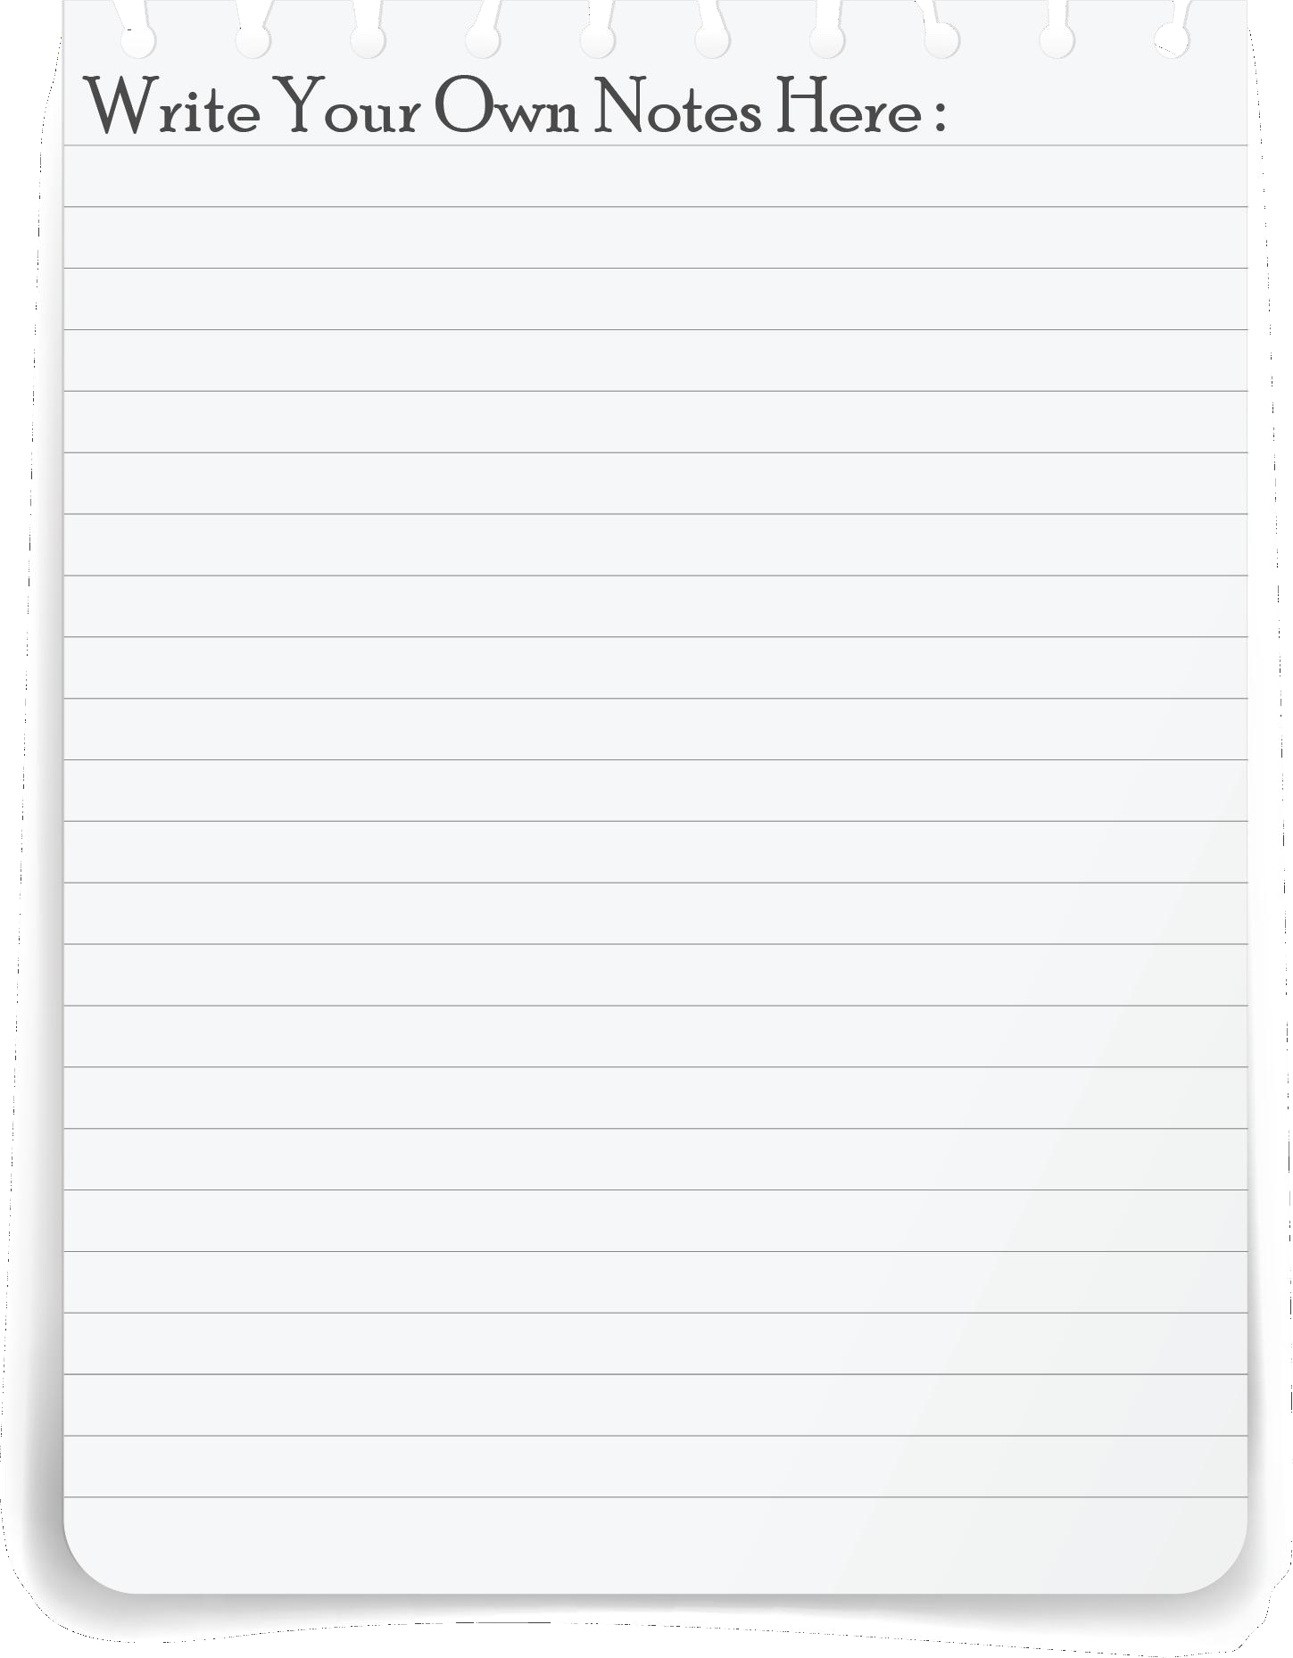

## Write a program to print first 10 natural number in reverse order using while loop.

Program:

num = 10

while num >= 1: print(num) num= num - 1

Output:

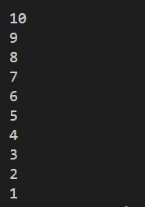

## Write a program to find the product of the digits of a number accepted from the user.

Program:

num1 = int(input("Enter any number : ")) r=0

p=1 while(num1!=0):

r = num1 % 10 p = p * r

num1 = num1//10

print("Product of the digits are : " , p)

Output:



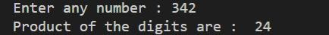

## Write a program to display the number names of the digits of a number entered by user, for example if the number is 231 then output should be Two Three One

Program:

num1 = input("Enter any number : ") L1 = list(num1)

L = len(L1) i=0

n = {0 : "Zero", 1 : "One", 2 : "Two", 3 : "Three", 4 :

"Four", 5 : "Five", 6 : "Six", 7 : "Seven", 8 : "Eight",

9 : "Nine"} while (i < L):

print(n[int(L1[i])], end = " ") i = i + 1

Output:

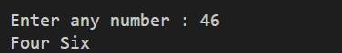

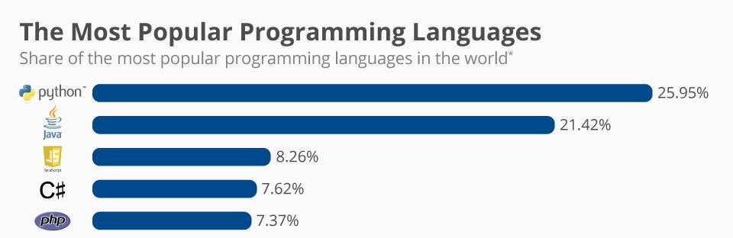

## Write a Program to print all the characters in the string ‘OCEAN’ using while loop.

Program:

str = "OCEAN"

i = 0 while(i<len(str)):

print(str[i]) i = i + 1

Output:

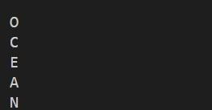

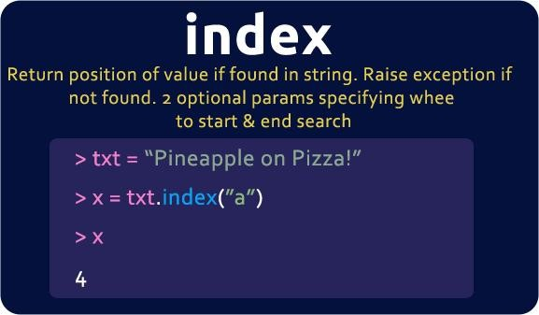

## Write a program to print all the factors of a number using for loop.

Program:

n = int(input("Enter any number")) print("Factors are : ")

i = 1

while(i <= n):

if n % i == 0 : print(i)

i = i + 1

Output:

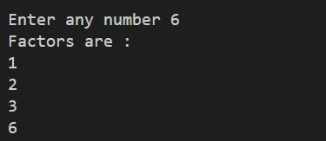

For loop basic programs:

for syntax:

for iterating variable in (start, end, step): statement

## Write a program to find the factorial of a number.

Program:

fact=1

n=int(input("Enter the range")) for i in range (1,n+1):

fact = fact*i print(fact)

Output:

# ocean academy

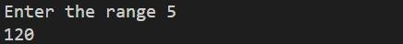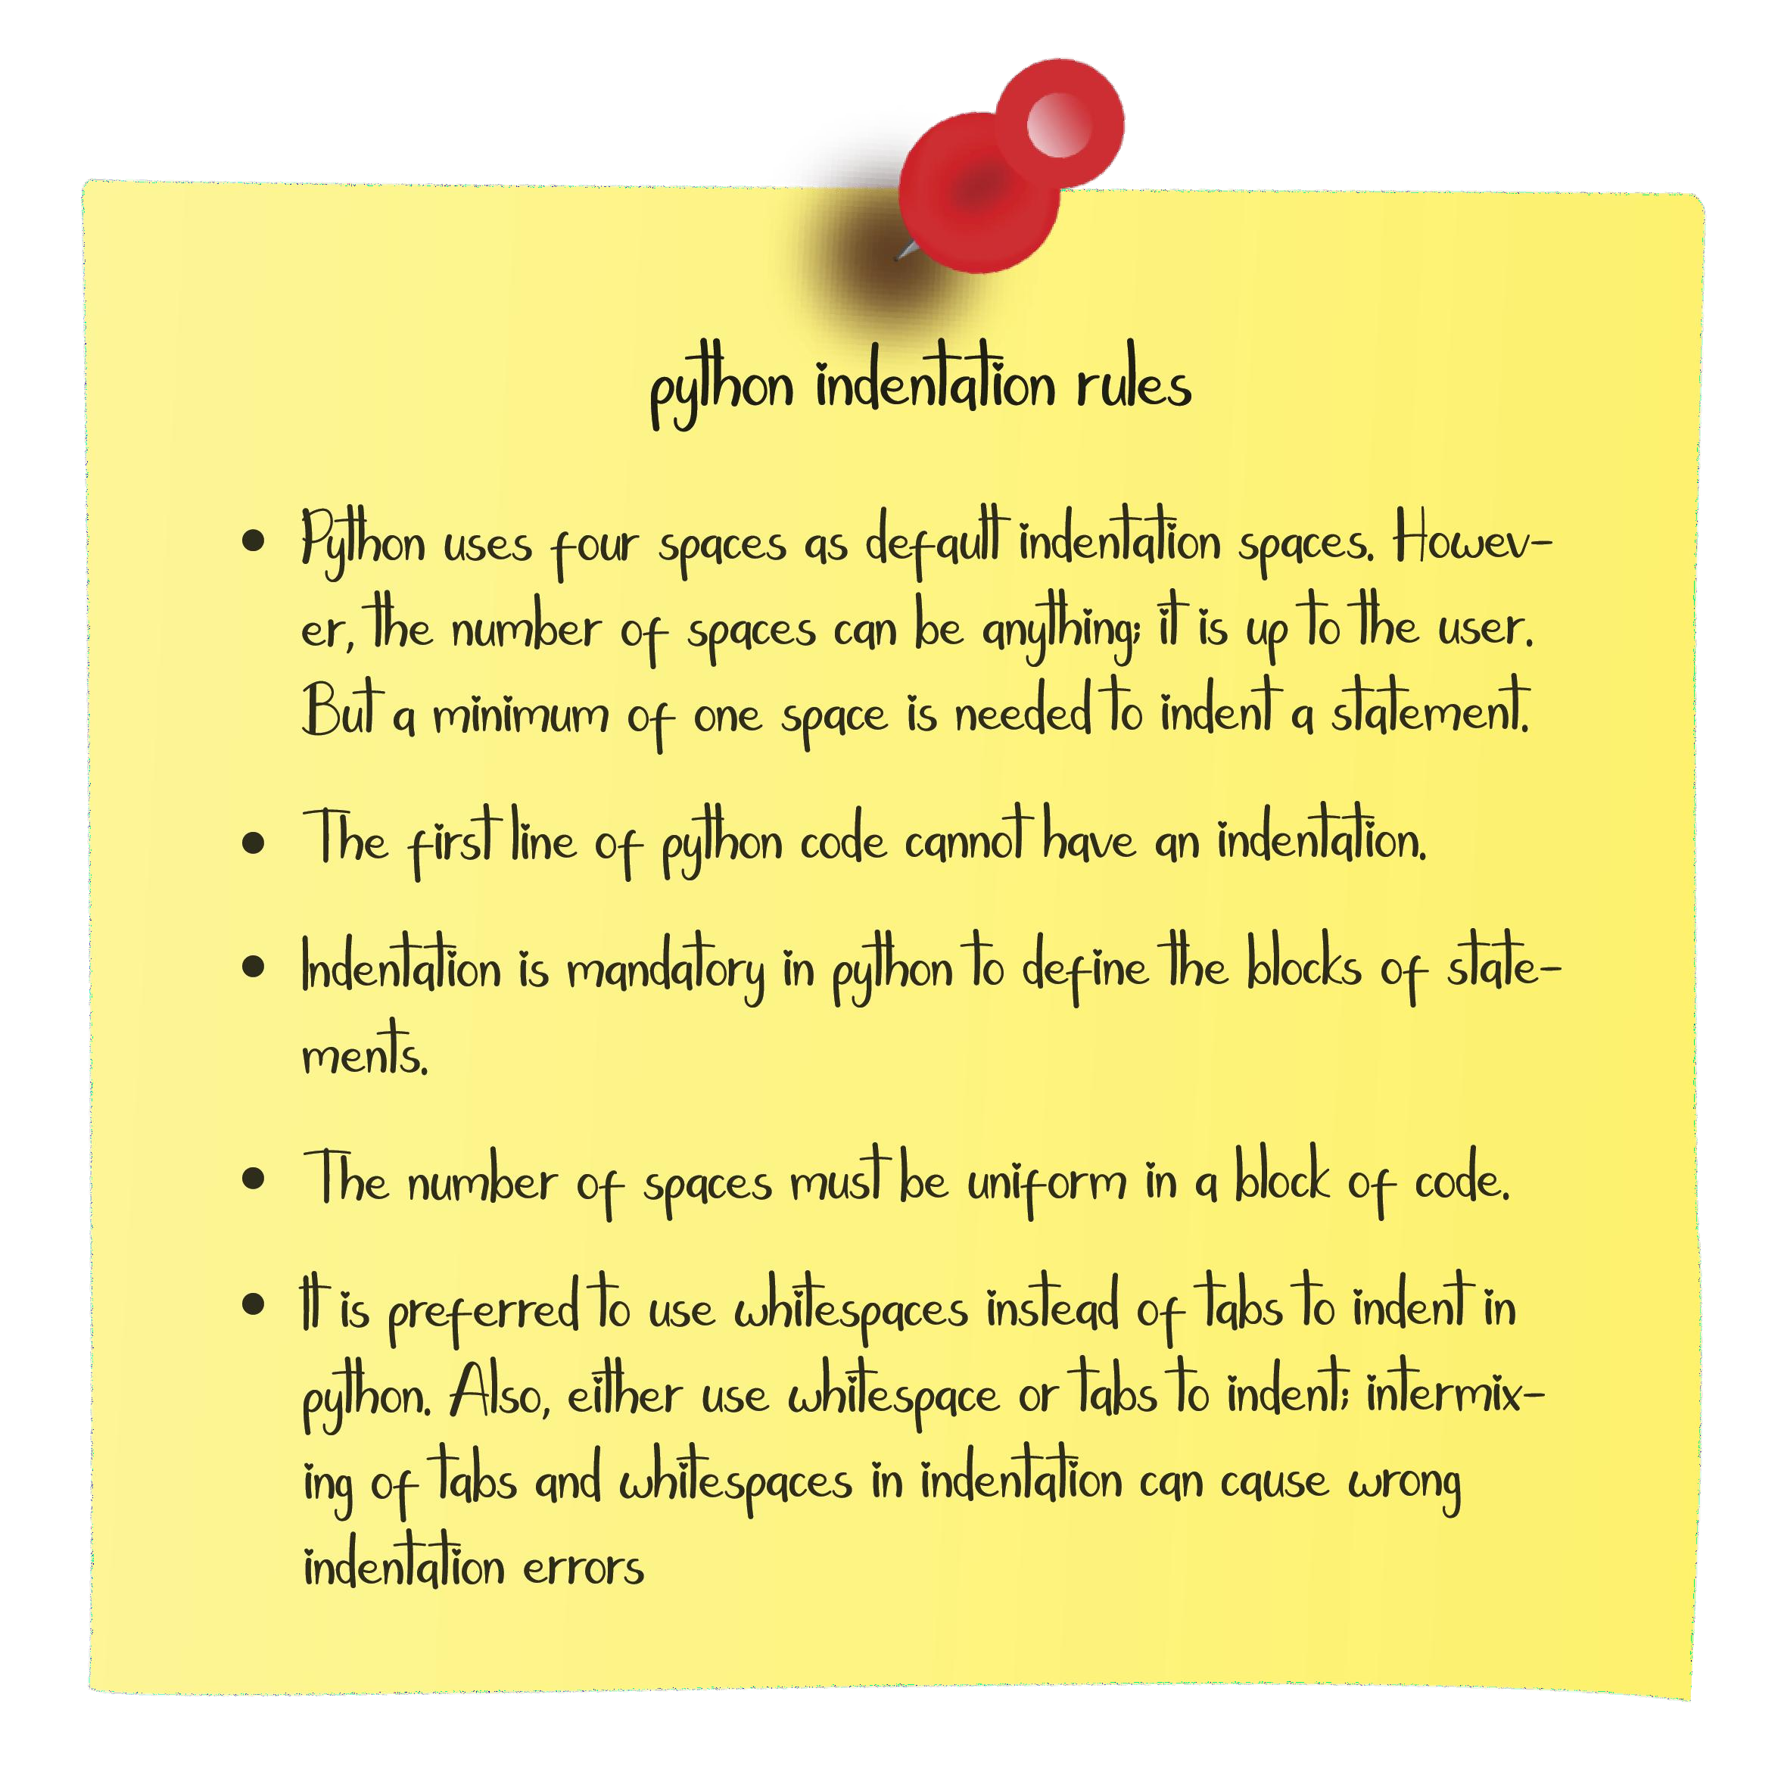

## Write a program to check whether a number is prime or not.

Program:

num=int(input("Enter any number")) f=0

if num==1 or num==0: f=1

for i in range(2,num): if num%i==0:

f=1

if f==1:

print("Number is not prime") else:

print("Number is prime")

Output:

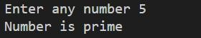

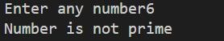

## Write a program to find the fibonacci series of a number.

Program:

a=-1

b=1

n=int(input("Enter the number")) for i in range(1,n+1):

c=a+b a=b b=c print©

Output:

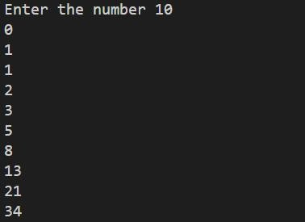

## Print the below pattern.

*

## * *

* * *

## * * * *

Program:

for i in range(1,6): for j in range(1,i):

print("* ",end="") print()

Output:

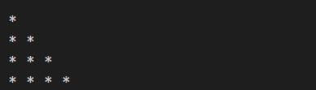

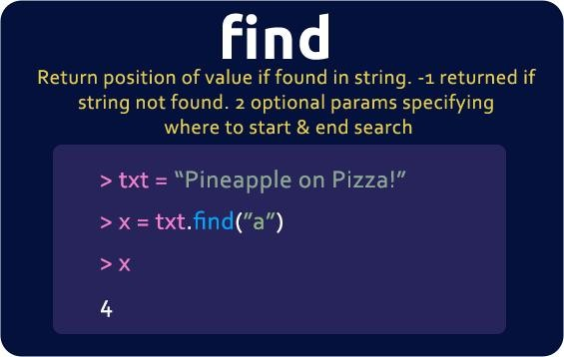

## Print the below pattern

* *

* *

*

* *

* *

Program:

rows=int(input("enter the rows") for i in range(0, rows):

for j in range(0, rows):

if(i == j or j == rows- 1 - i): print("*", end = '')

else:

print(' ', end = '')

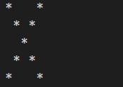print() Output:

## Print the below pattern

1

## 2 2

3 3 3

## 4 4 4 4

5 5 5 5 5

Program:

rows = 6

for num in range(rows): for i in range(num):

print(num, end=" ") print(" ")

Output:

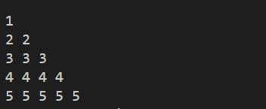

## Print the below pattern

0 0 0 0 0 0

1 1 1 1 1 1

2 2 2 2 2 2

3 3 3 3 3 3

4 4 4 4 4 4

5 5 5 5 5 5

Program:

rows = 6

for i in range(rows): for j in range(rows):

print(i, end=" ") print()

Output:

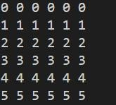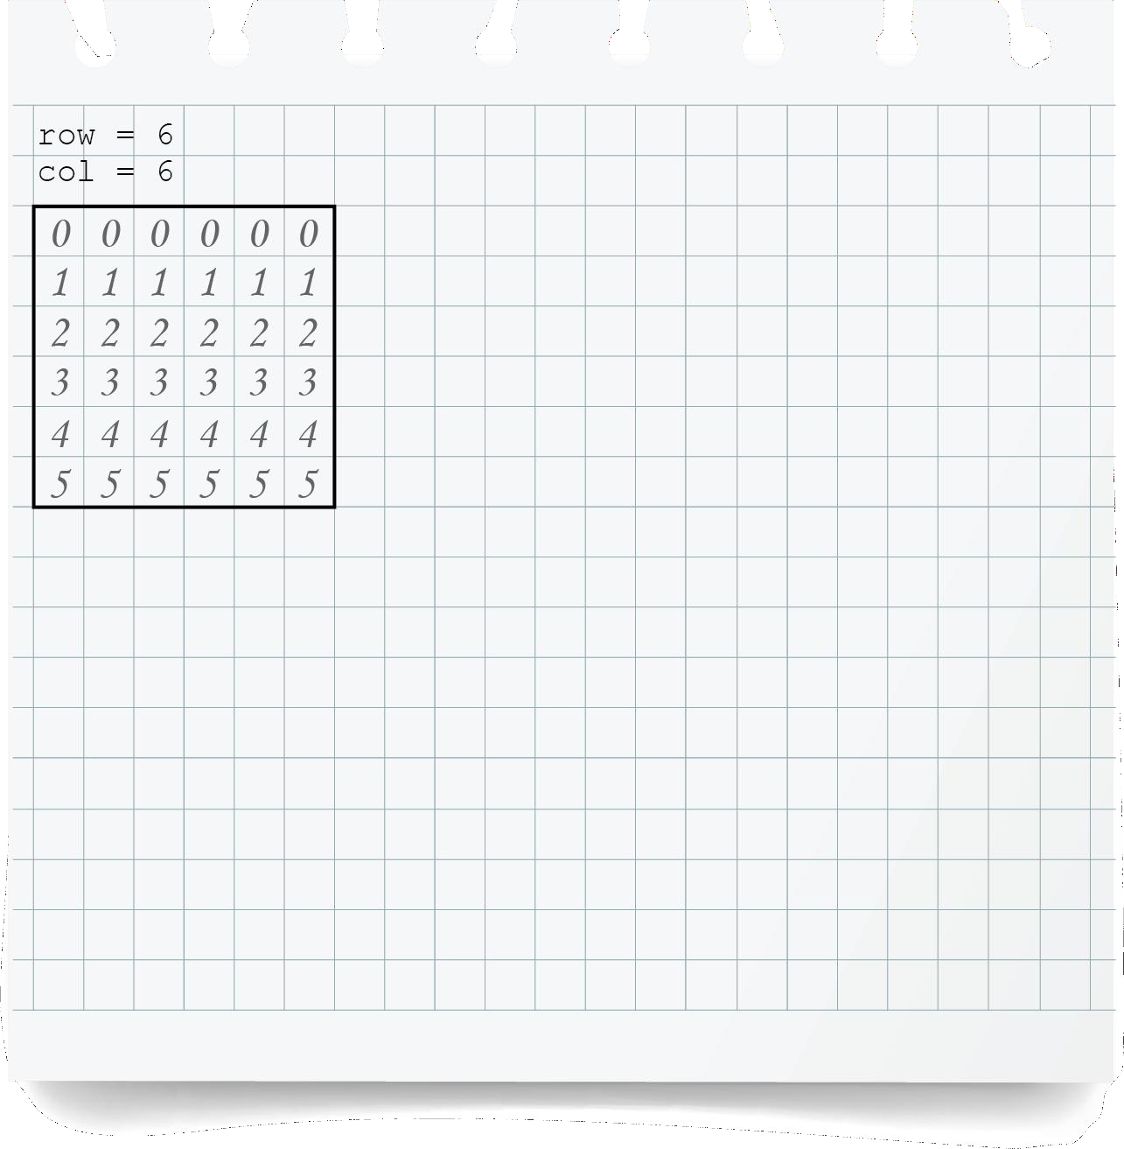

## Print the below pattern

|  |  |  |  |  |  |
| --- | --- | --- | --- | --- | --- |
| **0** | **1** | **2** | **3** | **4** | **5** |
| **0** | **1** | **2** | **3** | **4** | **5** |
| **0** | **1** | **2** | **3** | **4** | **5** |
| **0** | **1** | **2** | **3** | **4** | **5** |
| **0** | **1** | **2** | **3** | **4** | **5** |
| **0** | **1** | **2** | **3** | **4** | **5** |

Program:

rows = 6

for i in range(rows): for j in range(rows):

print(j, end=" ") print()

Output:

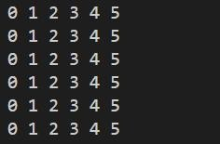

## Print the below pattern

A A A A A B B B B B C C C C C D D D D D E E E E E

Program:

rows = 6

for i in range(1,rows): for j in range(1,rows):

print(chr(64+i), end=" ") print()

Output:

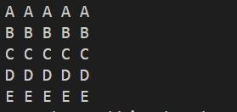

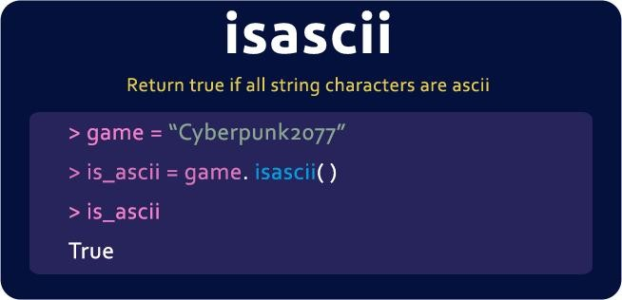

## Print the below pattern

|  |  |  |  |  |
| --- | --- | --- | --- | --- |
| **A** | **B** | **C** | **D** | **E** |
| **A** | **B** | **C** | **D** | **E** |
| **A** | **B** | **C** | **D** | **E** |
| **A** | **B** | **C** | **D** | **E** |
| **A** | **B** | **C** | **D** | **E** |

Program:

rows = 6

for i in range(1,rows): for j in range(1,rows):

print(chr(64+j), end=" ") print()

Output:

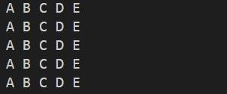

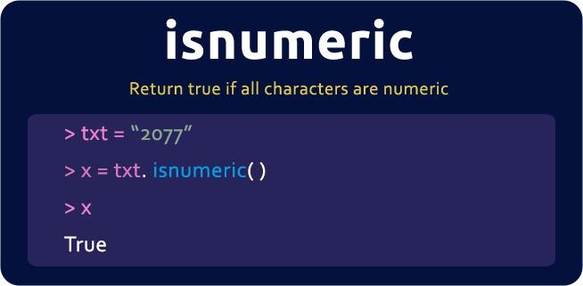

## Print the below pattern

* * * *

* * *

* *

* Program:

for i in range(4,0,-1):

for j in range(i): print("*",end=" ")

print()

Output:

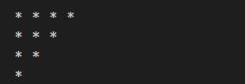

## Write a program to print the following pattern

5 5 5 5 5

4 4 4 4

3 3 3

2 2

1

Program:

for i in range(5,0,-1): for j in range(1,i+1):

print(i,end=" ") print()

Output:

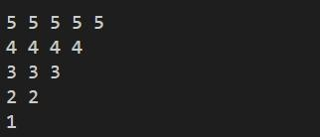

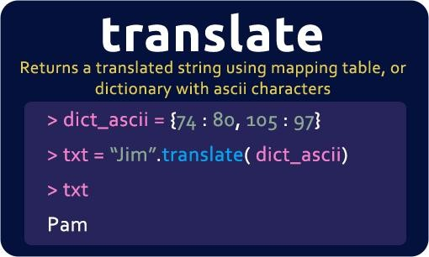

## Write a program to print the following pattern

A B C

D E F G H I J

K L M N O

Program:

l=65

for i in range(1,6):

for j in range(1,i+1): print(chr(l),end=" ") l=l+1

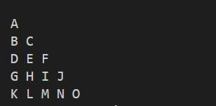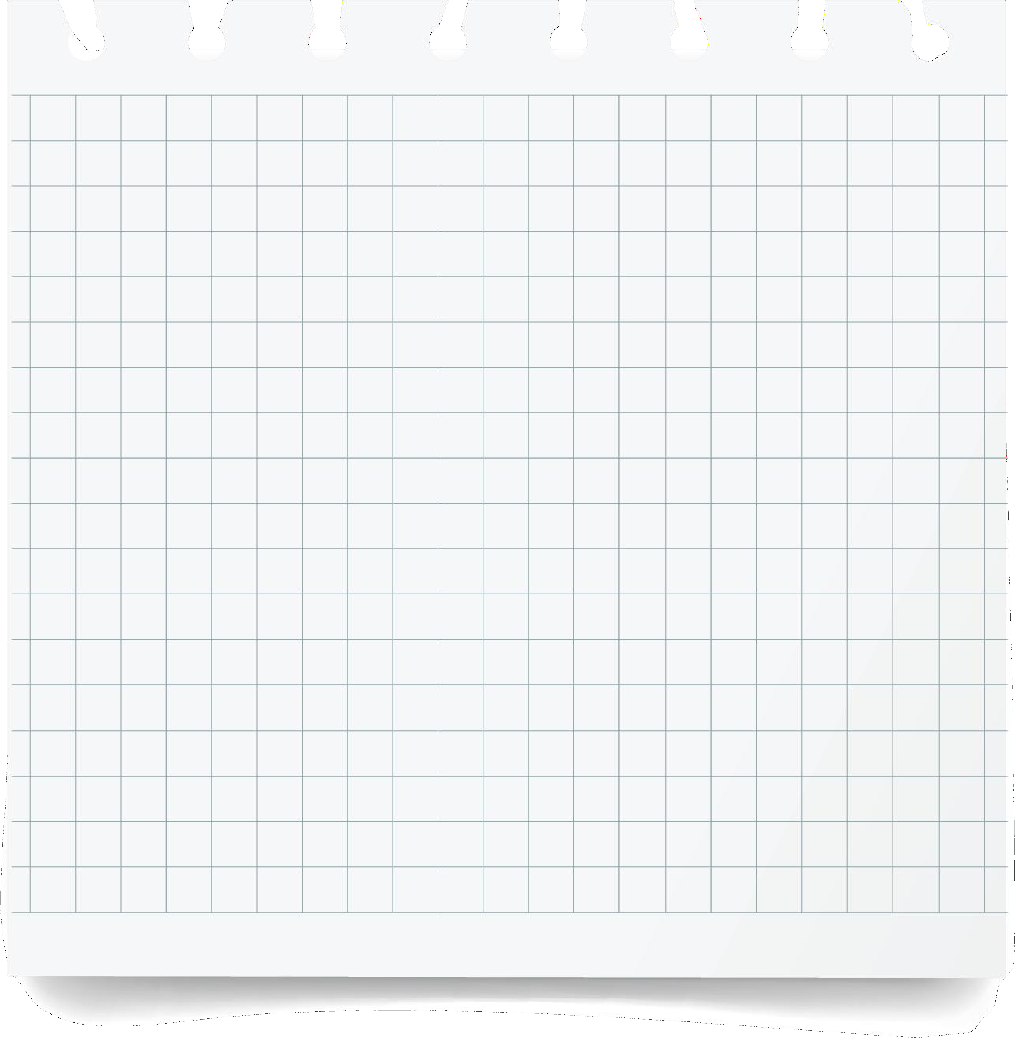print() Output:

## Write a program to print the following pattern

1

1 2

1 2 3

1 2 3 4

1 2 3 4 5

Program:

rows = 5

for i in range(1, rows + 1): for j in range(1, i + 1):

print(j, end=' ')

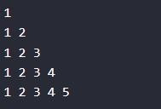print('') Output:

## Write a program to print the following pattern

1 1 1 1 1

2 2 2 2

3 3 3

4 4

5

Program:

rows = 5

b = 0

for i in range(rows, 0, -1):

b += 1

for j in range(1, i + 1): print(b, end=' ')

print('\r')

Output:

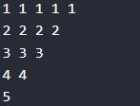

## Write a program to print the following pattern

1

3 3

5 5 5

7 7 7 7

9 9 9 9 9

Program:

rows = 5

i = 1

while i <= rows: j = 1

while j <= i:

print((i * 2 - 1), end=" ") j = j + 1

i = i + 1 print('')

Output:

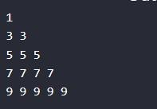

## Write the following pattern

1

2 1

3 2 1

4 3 2 1

5 4 3 2 1

Program:

rows = 6

for i in range(1, rows):

for j in range(i, 0, -1): print(j, end=' ')

print("")

Output:

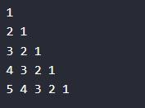

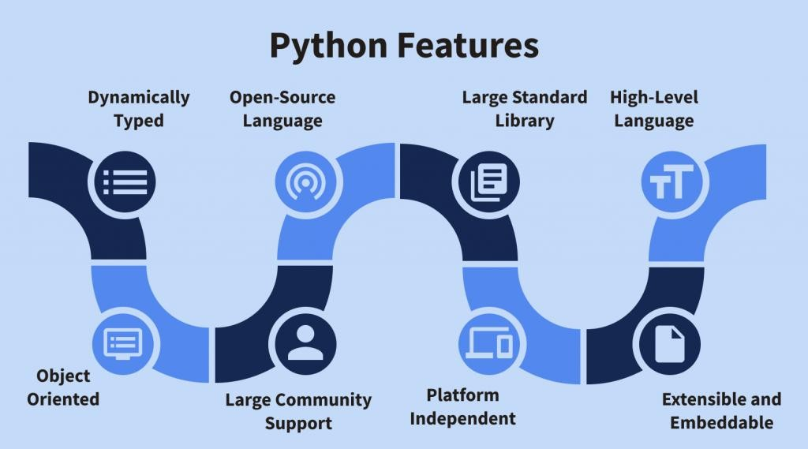

## Write a program to following pattern

5 4 3 2 1

4 3 2 1

3 2 1

2 1

1

Program:

rows = 5

for i in range(0, rows + 1):

for j in range(rows - i, 0, -1): print(j, end=' ')

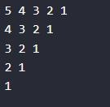print() Output:

## Write a program to following pattern

1

3 2

6 5 4

10 9 8 7

Program:

start = 1

stop = 2 current_num = stop

for row in range(2, 6):

for col in range(start, stop): current_num -= 1 print(current_num, end=' ')

print("") start = stop stop += row

current_num = stop

Output:

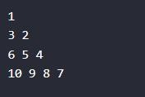

## Write the following a print pattern

1

2 4

3 6 9

4 8 12 16

5 10 15 20 25

6 12 18 24 30 36

7 14 21 28 35 42 49

8 16 24 32 40 48 56 64

Program:

rows = 8

for i in range(1, rows + 1): for j in range(1, i + 1):

square = i * j print(i * j, end=' ')

print()

Output:

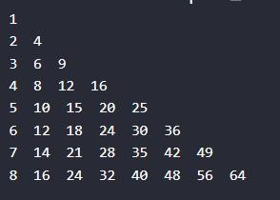

List basic programs:

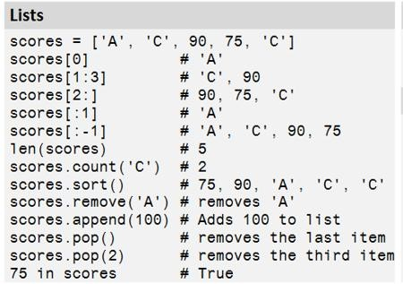

## Given an array of ints, return True if 6 appears as either the first or last element in the array. The array will be length 1 or more.

first_last6([1, 2, 6]) → True

## first_last6([6, 1, 2, 3]) → True

first_last6([13, 6, 1, 2, 3]) → False

Program:

def first_last6(nums):

return nums[0] == 6 or nums[-1] == 6 print(first_last6([1, 2, 6]))

Output:

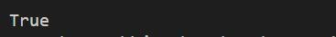

## Given an array of ints, return True if the array is length 1 or more, and the first element and the last element are equal.

same_first_last([1, 2, 3]) → False

## same_first_last([1, 2, 3, 1]) → True

same_first_last([1, 2, 1]) → True

Program:

def same_first_last(nums):

return len(nums) >= 1 and nums[0] == nums[-1] print(same_first_last([1, 2, 3, 1]))

Output:



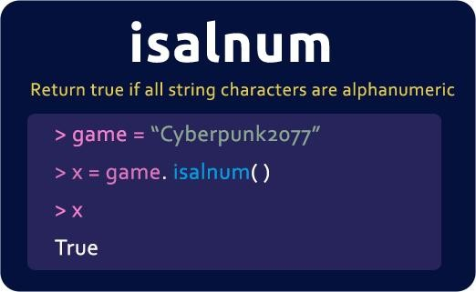

## Return an int array length 3 containing the first 3 digits of pi, {3, 1, 4}.

make_pi() → [3, 1, 4]

Program:

def make_pi(): return [3, 1, 4]

print(make_pi())

Output:



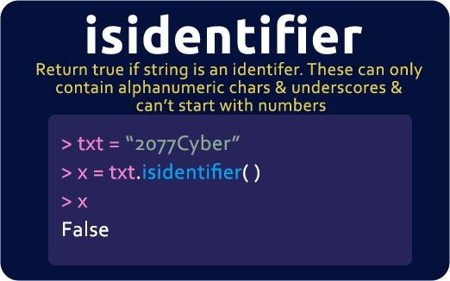

## Write a program to sum all items in a list.

Program:

a=[]

sum=0

n=int(input("enter the range of list")) for i in range(0,n):

b=int(input("enter the value")) a.append(b)

sum=sum+a[i] print(sum)

Output:

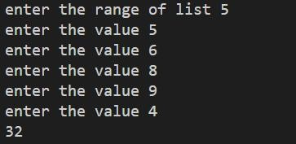

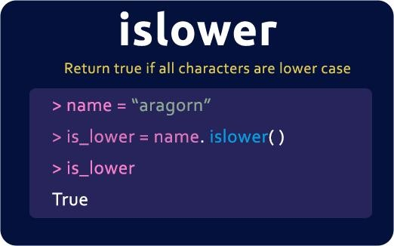

## Write a program to interchange the first and last element in the list.

Program:

a=[]

sum=0

n=int(input("enter the range of list")) for i in range(0,n):

b=int(input("enter the value")) a.append(b)

print(a) size=len(a) temp=a[0] a[0]=a[size-1] a[size-1]=temp print(a)

Output:

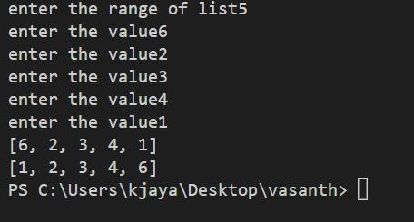

## Write a program to reverse a list.

Program:

a=[]

sum=0

n=int(input("enter the range of list")) for i in range(0,n):

b=int(input("enter the value")) a.append(b)

print(a) a.reverse() print(a)

Output:

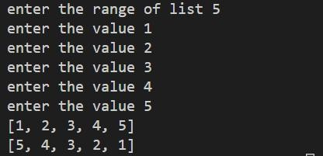

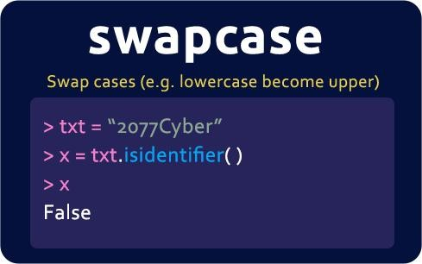

## Write a program to find the smallest and largest element in the list without using a max and min method.

Program:

sum=0

n=int(input("enter the range of list")) for i in range(0,n):

b=int(input("enter the value")) a.append(b)

print(a) highest_number=0 lowest_number=a[0] for i in a:

if i > highest_number: highest_number=i

if i < lowestnumber: lowestnumber=i

print(lowest_number) print(highest_number)

Output:

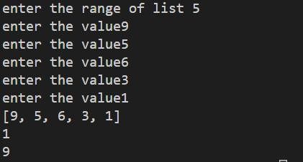

## Write a program in ascending order in the list.

Program:

sum=0

n=int(input("enter the range of list")) for i in range(0,n):

b=int(input("enter the value")) a.append(b)

print(a)

for i in range (n):

for j in range(i+1,n): if(a[i]>a[j]):

a[i],a[j]=a[j],a[i]

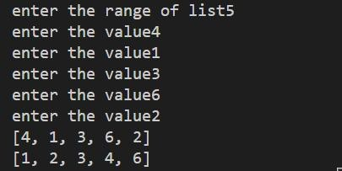print(a) Output:

## Write a program in descending order in the list.

Program:

sum=0

n=int(input("enter the range of list")) for i in range(0,n):

b=int(input("enter the value")) a.append(b)

print(a)

for i in range (n):

for j in range(i+1,n): if(a[i]<a[j]):

a[i],a[j]=a[j],a[i]

print(a)

Output:

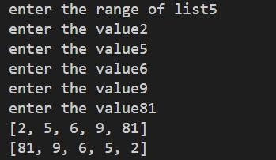

## Write a program to reverse a number in a list without using a reverse function.

Program:

sum=0

n=int(input("enter the range of list")) for i in range(0,n):

b=int(input("enter the value")) a.append(b)

print(a) l=len(a)

for i in range(int(l/2)): a[i],a[l-i-1]=a[l-i-1],a[i]

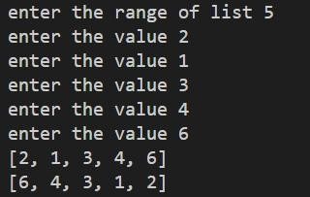print(a) Output:

Set basic programs:

Define a set:

programingLanguages = {'Python', 'R', 'SQL', 'Git', 'Tableau','R', 'SASS'}

OR

programingLanguages = set(['Python', 'R', 'SQL', 'Git', 'Tableau', 'SASS'])

Add element in a set:

programingLanguages = {'Python', 'R', 'SQL', 'Git', 'Tableau','R', 'SASS'}

programingLanguages.add('c++') Output:

|  |  |  |
| --- | --- | --- |
| **Remove element in a set:** |  | |
| **programingLanguages = {'Python', 'R', 'Tableau', 'SASS'} programingLanguages.remove('SASS') print(programingLanguages)** | **'SQL',** | **'Git',** |
| **Output:** |  |  |



|  |  |  |  |
| --- | --- | --- | --- |
| **Remove random element in a set:** |  | | |
| **programingLanguages = {'Python', 'Tableau', 'SASS'} programingLanguages.pop() print(programingLanguages)** | **'R',** | **'SQL',** | **'Git',** |
| **Output:** |  |  |  |



Clear all element in a set:

programingLanguages = {'Python', 'R', 'SQL', 'Git', 'Tableau',''SASS'}

programingLanguages.clear() print(programingLanguages)

Output:



Union:

programingLanguages = {'Python', 'R', 'SQL', 'Git', 'Tableau', 'SASS'}

program={'java','c++',"SASS"}

union = programingLanguages.union(program) print(union)

Output:



Intersection:

programingLanguages = {'Python', 'R', 'SQL', 'Git', 'Tableau', 'SASS'}

program={'java','c++',"SASS"}

intersection = programingLanguages.intersection(program) print(intersection)

Output:

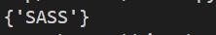

Difference:

programingLanguages = {'Python', 'R', 'SQL', 'Git', 'Tableau', 'SASS'}

program={'java','c++',"SASS"}

difference = programingLanguages.difference(program) print(difference)

Output:



Symmetric Difference:

programingLanguages = {'Python', 'R', 'SQL', 'Git', 'Tableau', 'SASS'}

program={'java','c++',"SASS"} symmetricdifference = programingLanguages.symmetric_difference(program) print(symmetricdifference)

Output:



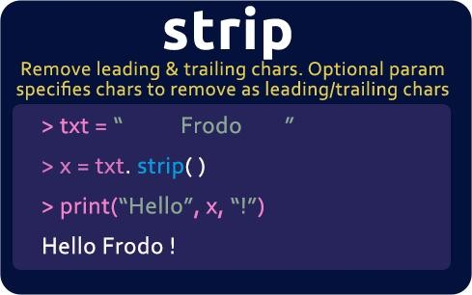

## Write a python program to count the number of vowels in a given string.

Program:

def vowel_count(str): count = 0

vowel = set("aeiouAEIOU") for alphabet in str:

if alphabet in vowel: count = count + 1

print("No. of vowels :", count) str = "OceanAcademy" vowel_count(str)

Output:



Tuples basic programs:

Define a Tuple:

programingLanguages = ('Python', 'R', 'SQL', 'Git', 'Tableau', 'SASS')

print(programingLanguages)

Output:



Add a value into tuple:

programingLanguages = ('Python', 'R', 'SQL', 'Git', 'Tableau', 'SASS')

y=list(programingLanguages) y.append('C++') programingLanguages=tuple(y) print(programingLanguages)

Output:



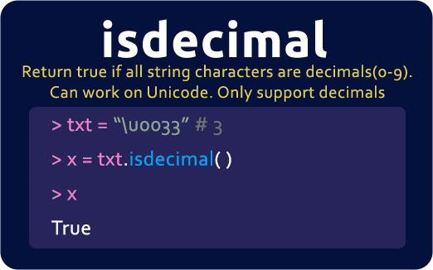

## Reverse the given tuple. input=(10,20,30,40,50) output=(50,40,30,20,10)

Program:

tuple1 = (10, 20, 30, 40, 50)

tuple1 = tuple1[::-1] print(tuple1) Output:



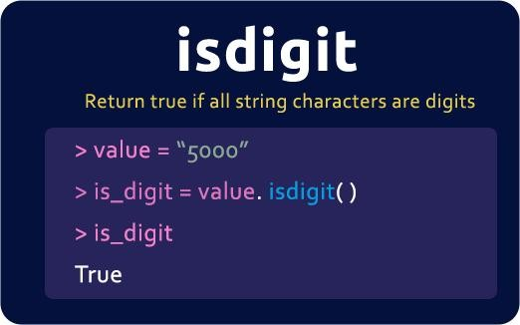

## Swap two tuples in a python .

Input

## tuple1 = (11, 22)

tuple2 = (99, 88) Expected Output tuple1: (99, 88)

## tuple2: (11, 22)

Program:

tuple1 = (11, 22)

tuple2 = (99, 88)

tuple1, tuple2 = tuple2, tuple1 print(tuple2)

print(tuple1)

]

Output:

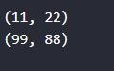

Dictionaries:

Define a Dictionaries:

dict = { "brand": "Ford", "model": "Mustang", "year": 1964}

print(dict) Output:

Get Keys:

dict = { "brand": "Ford", "model": "Mustang", "year": 1964}

print(dict.keys())

Output:



Get Values:

dict = { "brand": "Ford", "model": "Mustang", "year": 1964}

print(dict.values())

Output:



Change values in dictionary:

dict = { "brand": "Ford", "model": "Mustang", "year": 1964}

dict["year"]=2020 print(dict)

Output:



Update values in dictionary:

dict = { "brand": "Ford", "model": "Mustang", "year": 1964}

dict.update({"year":2020}) print(dict)

Output:



Adding items into dictionary:

dict = { "brand": "Ford", "model": "Mustang", "year": 1964}

dict['color']='red' print(dict)

Output:



Remove items from dictionary:

dict = { "brand": "Ford", "model": "Mustang", "year": 1964}

dict.pop('model') print(dict)

Output:



dict = { "brand": "Ford", "model": "Mustang", "year": 1964}

dict.popitem() print(dict)

Output:



Get input from user:

dict={}

for i in range (3): k=input("enter the key value")

dict[k]=input("enter the value") print(dict)

Output:

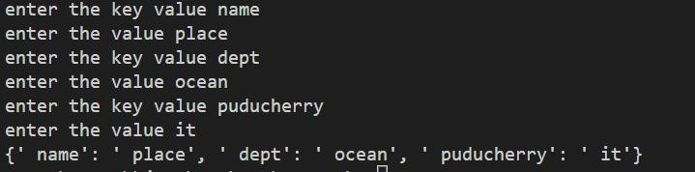

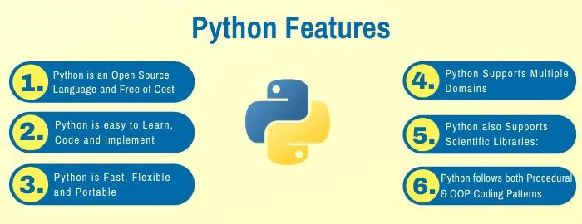

## write a program to list passed students.

Program:

student={}

n=int(input("enter the range")) for i in range (n):

a=input("enter the student name") student[a]=int(input("enter the student marks"))

print (student)

for i,j in student.items(): if j>=35:

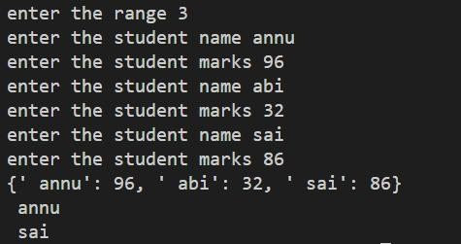print(i) Output:

## Write a Python script to concatenate the following dictionaries to create a new one.

Program:

dic1={1:10, 2:20}

dic2={3:30, 4:40}

dic3={5:50,6:60}

dic4 = {}

for d in (dic1, dic2, dic3): dic4.update(d) print(dic4)

Output:



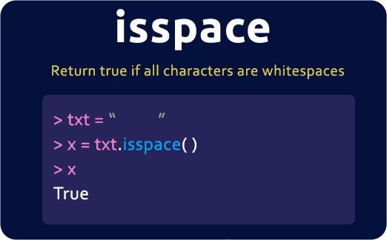

## Write a Python program to sum all the items in a dictionary.

Program:

dic={"a":1,"b":2,"c":4}

sum=0

for i in dic: sum=sum+dic[i]

print(sum) Output:

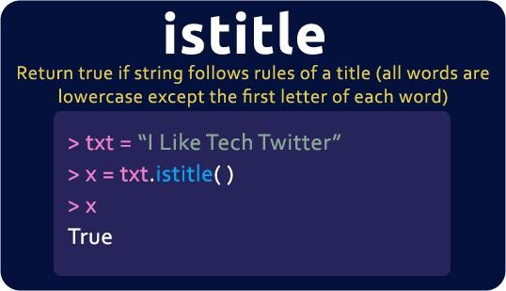

## Convert two list into a dictionary.

Program:

keys = ['Ten', 'Twenty', 'Thirty'] values = [10, 20, 30]

res_dict = dict()

for i in range(len(keys)): res_dict.update({keys[i]: values[i]})

print(res_dict)

Output:

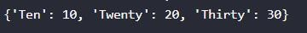

Function basic program:

Define a function:

Syntax:

def functionname(): statement

Program:

def myfunction(): print("hello world")

myfunction() Output:

## To find the length of the given string without using a built-in function.

Program:

def mystring(name): count=0

for i in name: count+=1

print(count) mystring("Hiocean")

Output:



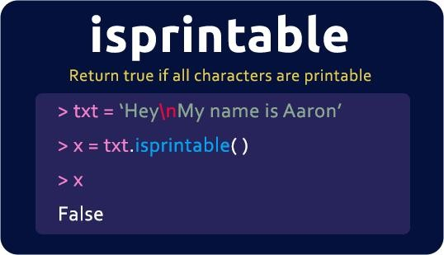

1. **To find the factorial number using a recursive function.**

Program:

def name(num): if(num==1):

return num else:

return num*name(num-1) print("factorial",name(5))

Output:



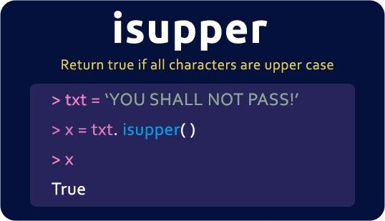

1. **Write a python program to reverse a string.**

Program:

def mystring(name): newstring='' b=len(name)-1

for i in range(b,-1,-1): newstring +=name[i]

return newstring print(mystring("oceanAcademy"))

Output:



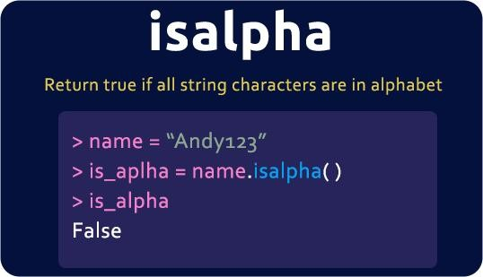

1. **Write a python program to determine if a string is palindrome or not.**

Program:

def mystring(name): newstring='' b=len(name)-1

for i in range(b,-1,-1): newstring+=name[i]

if(newstring==name): print("palindrome")

else:

print("not palindrome") mystring("liril")

Output:



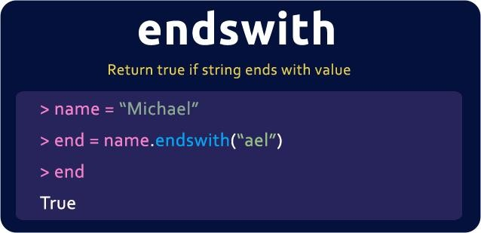

Module:

## basic.py

a=int(input("enter the value")) b=int(input("enter the value")) def sum(a,b):

print("result",a+b) basic1.py

from basic import *;

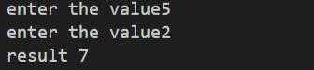sum(a,b) Output:

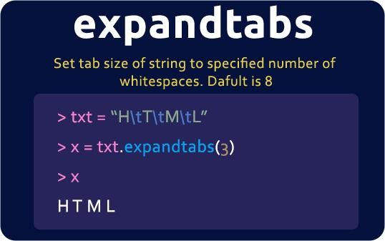

File handling:

## Write:

Program:

uname=input("enter your name") f=open("data.txt",'w') f.write(uname+"\n"+uname+"\n"+uname) f.close()

Output:

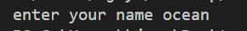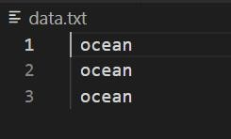

Read:

Program:

f=open("data.txt",'r') for i in f:

print(i,end="") f.close()

Output:

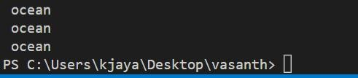

String basic programs:

## Given a string name, e.g. "Bob", return a greeting of the form "Hello Bob!".

hello_name('Bob') → 'Hello Bob!' hello_name('Alice') → 'Hello Alice!' hello_name('X') → 'Hello X!'

Program:

def hello_name(name): return "Hello "+name+"!"

print(hello_name("ocean")) Output:

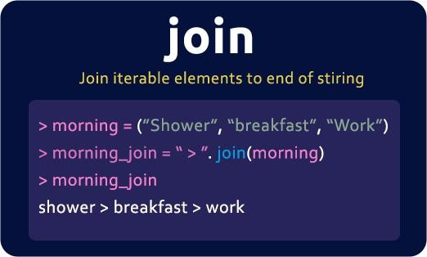

## Given two strings, a and b, return the result of putting them together in the order abba, e.g. "Hi" and "Bye" returns "HiByeByeHi".

make_abba('Hi', 'Bye') → 'HiByeByeHi' make_abba('Yo', 'Alice') → 'YoAliceAliceYo' make_abba('What', 'Up') → 'WhatUpUpWhat'

Program:

def make_abba(a,b): return a+b+b+a

print(make_abba("ocean","academy")) Output:

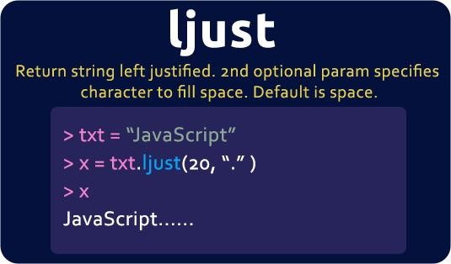

## The web is built with HTML strings like "<i>Yay</i>" which draws Yay as italic text. In this example, the "i" tag makes

<i> and </i> which surround the word "Yay". Given tag and word strings, create the HTML string with tags around the word, e.g. "<i>Yay</i>".

make_tags('i', 'Yay') → '<i>Yay</i>' make_tags('i', 'Hello') → '<i>Hello</i>' make_tags('cite', 'Yay') → '<cite>Yay</cite>'

Program:

def make_tags(tag,word):

return "<"+tag+">"+word+"</"+tag+">" print(make_tags("ocean","academy"))

Output:



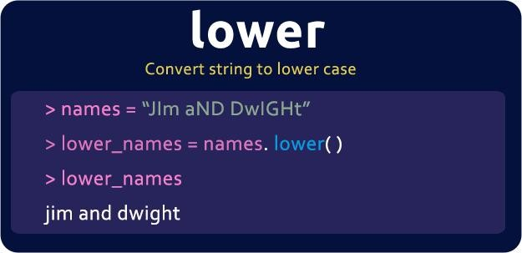

## Given an "out" string length 4, such as "<<>>", and a word, return a new string where the word is in the middle of the out string, e.g. "<<word>>".

make_out_word('<<>>', 'Yay') → '<<Yay>>' make_out_word('<<>>', 'WooHoo') → '<<WooHoo>>' make_out_word('[[]]', 'word') → '[[word]]'

Program:

def make_out_word(out,word): return out[:2]+word+out[2:]

print(make_out_word("<<>>","academy"))

Output:

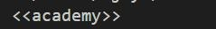

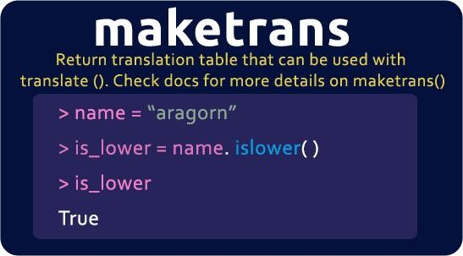

## Given a string, return a new string made of 3 copies of the last 2 chars of the original string. The string length will be at least 2.

extra_end('Hello') → 'lololo' extra_end('ab') → 'ababab' extra_end('Hi') → 'HiHiHi'

Program:

def extra_end(str): return str[-2:]*3

print(extra_end("academy")) Output:

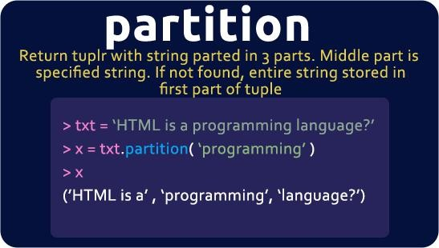

## Given a string, return the string made of its first two chars, so the String "Hello" yields "He". If the string is shorter than length 2, return whatever there is, so "X" yields "X", and the empty string "" yields the empty string "".

first_two('Hello') → 'He' first_two('abcdefg') → 'ab' first_two('ab') → 'ab'

Program:

def first_two(str): return str[:2]

print(first_two("Ocean")) Output:

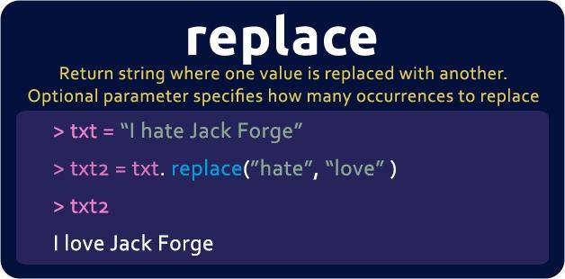

## Given a string of even length, return the first half. So the string "WooHoo" yields "Woo".

first_half('WooHoo') → 'Woo' first_half('HelloThere') → 'Hello' first_half('abcdef') → 'abc'

Program:

def first_half(str): return str[:len(str)//2]

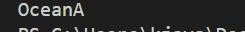print(first_half("OceanAcademy")) Output:

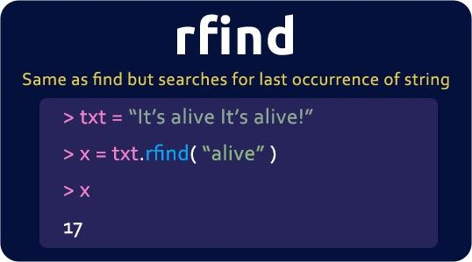

## Given 2 strings, return their concatenation, except omit the first char of each. The strings will be at least length 1.

non_start('Hello', 'There') → 'ellohere' non_start('java', 'code') → 'avaode' non_start('shotl', 'java') → 'hotlava'

Program:

def non_start(a, b): return a[1:]+b[1:]

print(non_start("Ocean","Academy")) Output:

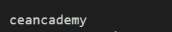

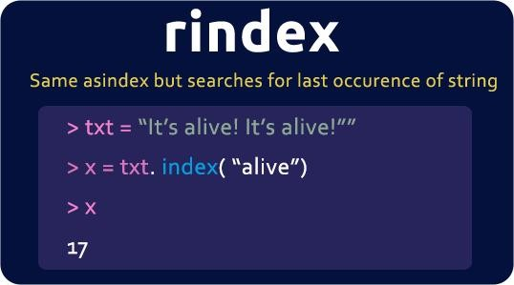

## ProgramGiven a string, return a "rotated left 2" version where the first 2 chars are moved to the end. The string length will be at least 2.

left2('Hello') → 'lloHe' left2('java') → 'vaja' left2('Hi') → 'Hi'

Program:

def left2(b): return b[2:]+b[:2]

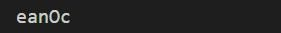print(left2("Ocean")) Output:

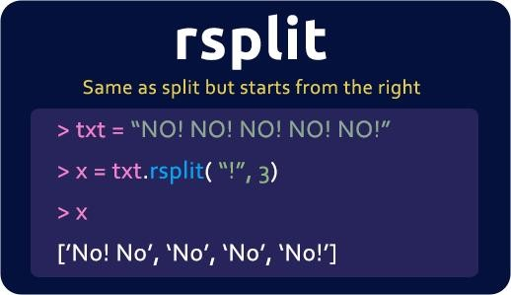

## Given a string, return a version without the first and last char, so "Hello" yields "ell". The string length will be at least 2.

without_end('Hello') → 'ell' without_end('java') → 'av' without_end('coding') → 'odin'

Program:

def without_end(str): return str[1:-1]

print(without_end("ocean")) Output:



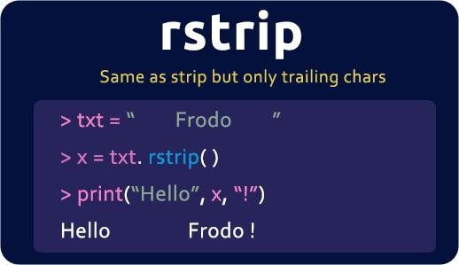

## Given 2 strings, a and b, return a string of the form short+long+short, with the shorter string on the outside and the longer string on the inside. The strings will not be the same length, but they may be empty (length 0).

combo_string('Hello', 'hi') → 'hiHellohi' combo_string('hi', 'Hello') → 'hiHellohi' combo_string('aaa', 'b') → 'baaab'

Program:

def combo_string(a, b): if len(a)>len(b):

return b+a+b else:

return a+b+a print(combo_string("ocean","academy"))

Output:



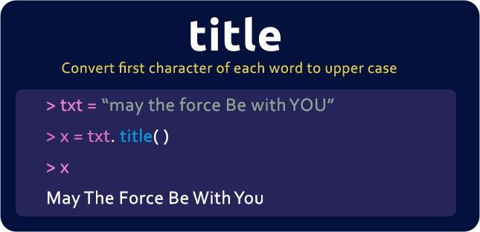

## Given a string, return a string where for every char in the original, there are two chars.

double_char('The') → 'TThhee' double_char('AAbb') → 'AAAAbbbb' double_char('Hi-There') → 'HHii--TThheerree'

Program:

def double_char(str): str1=''

for i in str: str1=str1+i+i

return str1 print(double_char("ocean"))

Output:



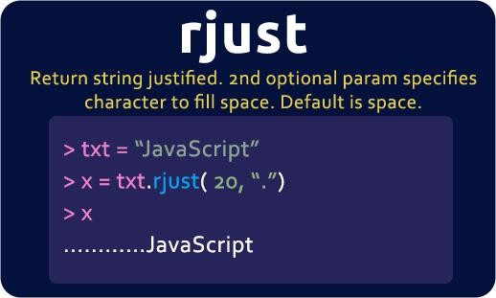

## Return the number of times that the string "hi" appears anywhere in the given string.

count_hi('abc hi ho') → 1 count_hi('ABChi hi') → 2 count_hi('hihi') → 2

Program:

def count_hi(str): count=0

for i in range(len(str)-1): if str[i:i+2]=='hi':

count+=1 return count

print(count_hi("hioceanhi"))

Output:



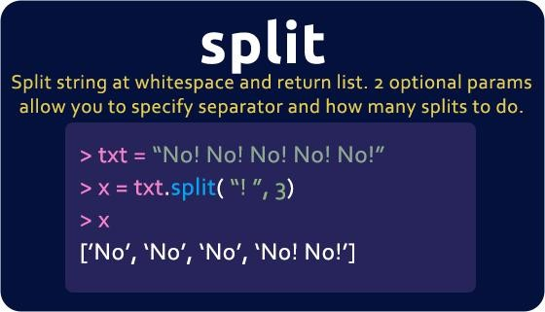

## Return True if the string "cat" and "dog" appear the same number of times in the given string.

cat_dog('catdog') → True cat_dog('catcat') → False cat_dog('1cat1cadodog') → True

Program:

def cat_dog(str): dogcount=0 catcount=0

for i in range(len(str)-1): if str[i:i+3]=='cat':

catcount+=1

if str[i:i+3]=='dog': dogcount+=1

if dogcount==catcount: return True

else:

return False print(cat_dog("catdogcadcodgog"))

Output:

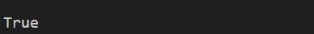

## Return the number of times that the string "code" appears anywhere in the given string, except we'll accept any letter for the 'd', so "cope" and "cooe" count.

count_code('aaacodebbb') → 1

count_code('codexxcode') → 2

count_code('cozexxcope') → 2

Program:

def count_code(str): count=0

for i in range(len(str)-3):

if str[i:i+2]=='co' and str[i+3]=='e': count+=1

return count print(count_code('aaacodebbb'))

Output:

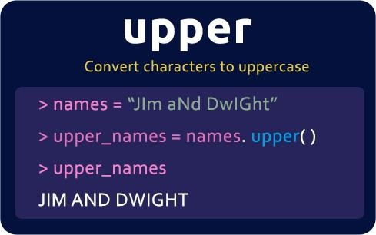

## Given two strings, return True if either of the strings appears at the very end of the other string, ignoring upper/lower case differences (in other words, the computation should not be "case sensitive"). Note: s.lower() returns the lowercase version of a string.

end_other('Hiabc', 'abc') → True end_other('AbC', 'HiaBc') → True end_other('abc', 'abXabc') → True

Program:

def end_other(a, b): a = a.lower()

b = b.lower()

#return (b.endswith(a) or a.endswith(b)) return a[-(len(b)):] == b or a == b[-(len(a)):]

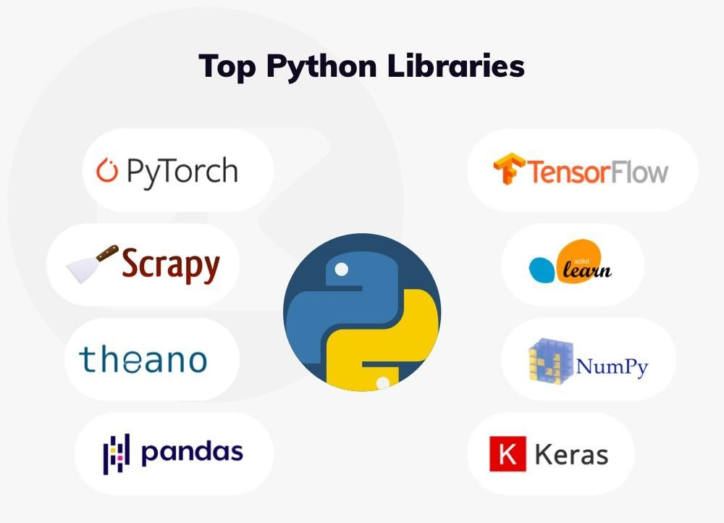print(end_other('Hiabc', 'abc')) Output:

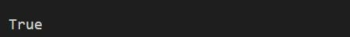

## Return True if the given string contains an appearance of "xyz" where the xyz is not directly preceeded by a period (.). So "xxyz" counts but "x.xyz" does not.

xyz_there('abcxyz') → True xyz_there('abc.xyz') → False xyz_there('xyz.abc') → True

Program:

def xyz_there(str):

for i in range(len(str)):

if str[i] != '.' and str[i+1:i+4] == 'xyz': return True

if str[0:3] == 'xyz': return True

return False print(xyz_there('abcxyz'))

Output:

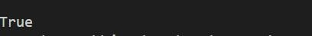



## Write a program to split a given string on hyphens and display each substring.

str1 = Ocean-academy-software-training-institute

Displaying each substring ocean

academy software training institute

Program:

str1 = "ocean-academy-software-training-institute" print("Original String is:", str1)

sub_strings = str1.split("-") print("Displaying each substring") for sub in sub_strings:

print(sub)

Output:

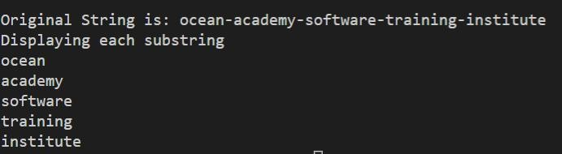

## Remove empty strings from a list of strings str_list = ["ocean", "academy", "", "software", None, "Institute", ""]

Expected Output:

Original list of sting

["ocean", "academy", "", "software", None, "Institute", ""]

After removing empty strings

["ocean", "academy", "software", "Institute"] Program:

str_list = ["ocean", "academy", "", "software", None, "Institute", ""]

res_list = []

for s in str_list:

# check for non empty string if s:

res_list.append(s) print(res_list)

Output:



## Write a program to given sample input and output

Input: Ocean

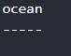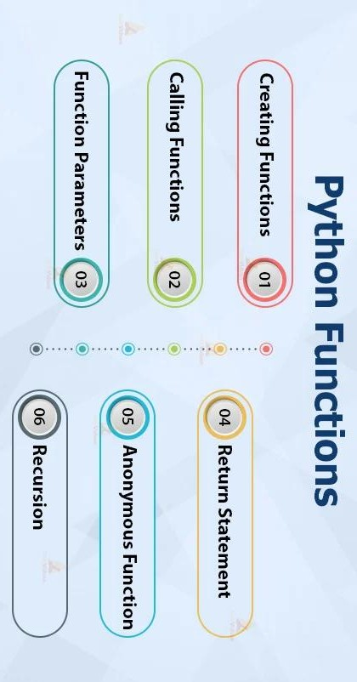Expected output:

Program:

str="ocean" b=len(str) print("ocean") print("-" * b)

Output:

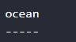

## Remove special symbols / punctuation from a string.

Given:

str1 = "/*ocean academy is @software & training // institute"

Expected Output:

"ocean academy is software training institute" Program:

import re

str1 = "/*ocean academy is @software & training // institute"

print("Original string is ", str1) res = re.sub(r'[^\w\s]', '', str1) print("New string is ", res)

Output:



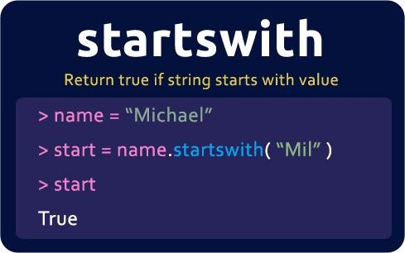

## Count all letters, digits, and special symbols from a given string.

Given: str1 = "P@#yn26at^&i5ve"

Expected output: Total counts of chars, digits, and symbols

Chars = 8

Digits = 3

Symbol = 4

Program:

def find_digits_chars_symbols(sample_str): char_count = 0

digit_count = 0

symbol_count = 0

for char in sample_str: if char.isalpha():

char_count += 1 elif char.isdigit():

digit_count += 1 else:

symbol_count += 1

print("Chars =", char_count, "Digits =", digit_count, "Symbol =", symbol_count)

sample_str = "P@yn2at&#i5ve"

print("total counts of chars, Digits, and symbols \n") find_digits_chars_symbols(sample_str)

Output:

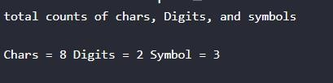

## Remove all characters from a string except integers.

Given: str1 = 'I am 25 years and 10 months old' Expected output: 2510

Program:

str1 = 'I am 25 years and 10 months old' print("Original string is", str1)

res = "".join([item for item in str1 if item.isdigit()]) print(res)

Output:

